

**PARK COLLEGE OF**

**ENGINEERING AND TECHNOLOGY**

**PROJECT REPORT**

**NaanMudhalvan–SalesforceDeveloper**

**Project Title:**Lease Management system

**TeamMembers:**

|  |  |  |
| --- | --- | --- |
| **Name** | **NMID** | **32digitNMID** |
| SHANMUGA PRIYA A (TL) | Au712221205034 | 6100459792EFE43B89A40248300C82A5 |
| SOWMIYA D | Au712221205037 | 13CCB616524DDBBA40E4EB9F7A7DB036 |
| AKCHAYA A | Au712221205004 | 76F8238B2216E91AEE64370436D46D41 |
| TIMPULDHARSHINI B | Au712221205041 | FD44426B081D5BBB9AB468B4A305F5AB |

Lease Management system

## ProjectDescription:

The **Lease Management System (LMS)** is an automated software solution designed to simplify the management of leases, contracts, payments, and associated documents for real estate properties, equipment, or any other rental agreements. It helps property managers, landlords, businesses, and leasing agents efficiently manage lease details in a centralized platform.

The system tracks essential lease information, such as start and end dates, rent amounts, payment schedules, and tenant details. It also sends automated reminders for lease renewals, payment due dates, and other important milestones. LMS manages rent payments, generates invoices and receipts, and tracks overdue payments or late fees. Additionally, it stores digital copies of lease agreements and other documents, making it easy to access and share them when needed.

For tenant management, the system maintains a database with contact information, payment history, and lease records. It also enables tenants to submit maintenance requests, which can be tracked for timely resolution. The LMS offers reporting tools for performance analysis and integrates with accounting systems for seamless financial management.

By automating processes, the Lease Management System improves operational efficiency, ensures regulatory compliance, and enhances the experience for both property owners and tenants, ultimately streamlining lease-related tasks.

## ProjectFlow:

Inthisprojectyoucandohandsonpracticetheconfigurationaswellascustomizationwith the Data modelling, App building, User Adoption & Apex Code

Milestone1:Creationofdeveloperaccount Milestone 2: Object Creation

Milestone3:TabsCreation Milestone 4 : Create App

Milestone5:Fields&Relationships Milestone 6 : Page LayoutMilestone 7 : Profile

Milestone8:Roleandrolehierarchy Milestone 9 : Users

Milestone10:Permissionset Milestone11:UserAdoption Milestone 12 : Reports Milestone 13 : Dashboards Milestone 14 : Flows

Milestone 15 : Apex Classes and Triggers

#### What you'll learn

1. RealTimeSalesforceProject
2. Object & Relationship in Salesforce
3. FormulafieldsandValidationrules.
4. Cross object formula fields.
5. Rollup summary fields.
6. Reports and dashboards
7. Conditional formatting.
8. Flows
9. Email alerts and email templates

**Milestone1-Salesforce:**

Introduction:

AreyounewtoSalesforce?Notsureexactlywhatitis,orhowtouseit?Don’tknowwhere you should start on your learning journey? If you’ve answered yes to any of these questions, then you’re in the right place. This module is for you.

Welcome to Salesforce! Salesforce is game-changing technology, with a host of productivity-boosting features, that will help you sell smarter and faster. As you work toward your badge for this module, we’ll take you through these features and answer the question, “What is Salesforce, anyway?”.

What Is Salesforce?

Salesforce is your customer success platform, designed to help you sell, service, market, analyze, and connect with your customers.

Salesforce has everything you need to run your business from anywhere. Using standard products and features, you can manage relationships with prospects and customers, collaborate and engage with employees and partners, and store your data securely in the cloud.

So what does that really mean? Well, before Salesforce, your contacts, emails, follow-uptasks, and prospective deals might have been organized something like this: <https://youtu.be/r9EX3lGde5k>

#### Activity1:CreatingDeveloperAccount:

Creatingadeveloperorginsalesforce.

1. Go to <https://developer.salesforce.com/signup>
2. On the sign up form, enter the following details :

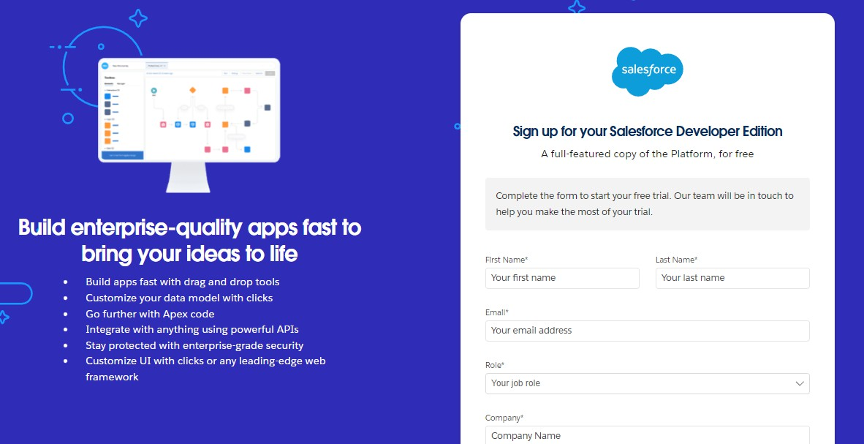

* 1. First name & Last name
  2. Email
  3. Role : Developer
  4. Company : College Name
  5. County : India
  6. Postal Code : pin code
  7. Username : should be a combination of your name and company Thisneednotbeanactualemailid,youcangiveanythingintheformat: [username@organization.com](mailto:username@organization.com)

Click on sign me up after filling these.

#### Activity 2: Account Activation:

1. Gototheinboxoftheemailthatyouusedwhilesigningup.Clickontheverifyaccount to activate your account. The email may take 5-10mins.

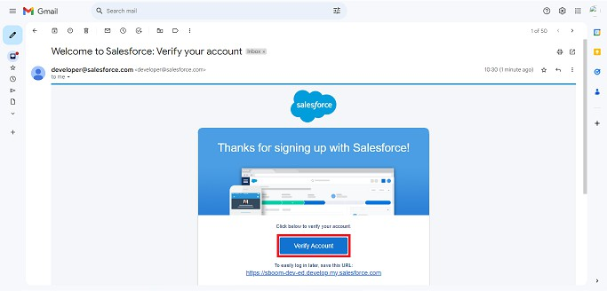

1. ClickonVerifyAccount
2. Give a password and answer a security question and click on change password.

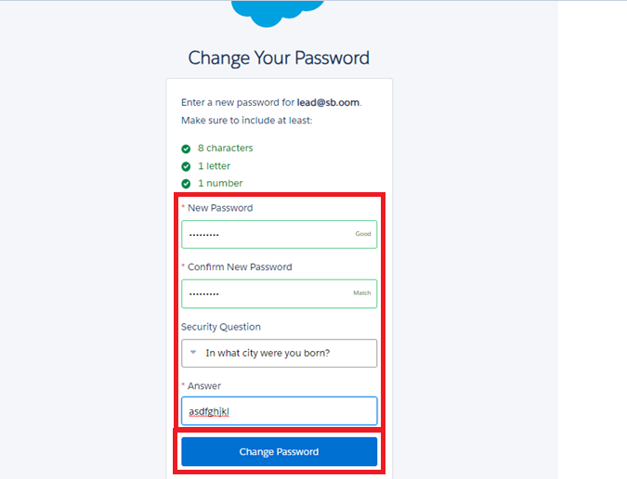

1. Then you will redirect to your salesforce setup page.

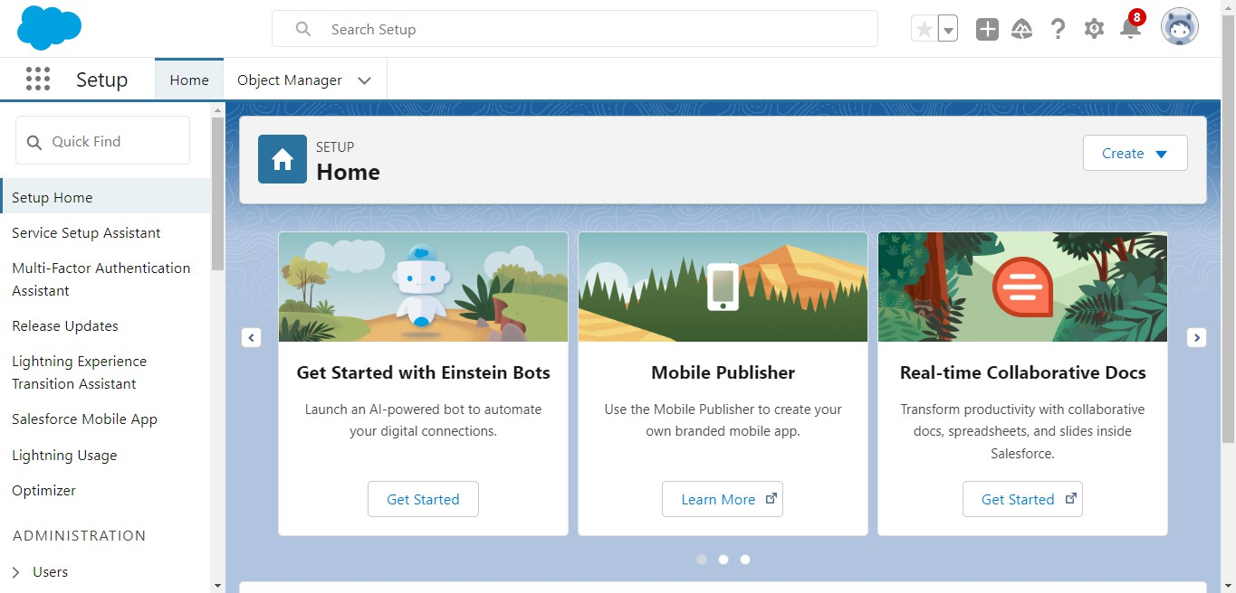

**Milestone2-Object**

WhatIsan Object?

Salesforce objects are database tables that permit you to store data that is specific to an organization. What are the types of Salesforce objects

#### Salesforceobjectsareoftwo types:

1. **Standard Objects**: Standard objects are the kind of objects that are provided by salesforce.com such as users, contracts, reports, dashboards, etc.
2. **Custom Objects:** Custom objects are those objects that are created by users. They supply information that isuniqueandessentialtotheirorganization.Theyaretheheart of any application and provide a structure for sharing data.

#### ToNavigatetoSetuppage:

Click on gear icon → click setup.

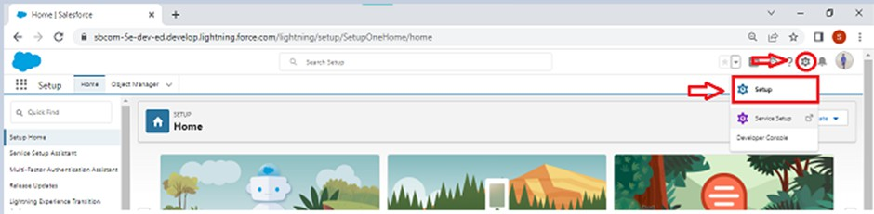

#### Tocreateanobject:

1. 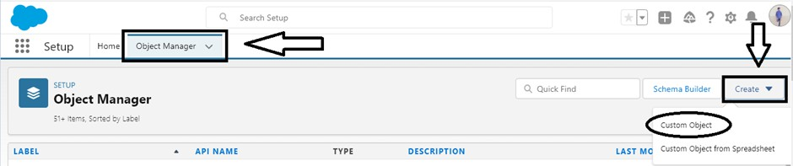Fromthesetuppage→ClickonObjectManager→ClickonCreate→ClickonCustom Object.
2. On Custom object defining page:
3. Enter the label name, plural label name, click on Allow reports, Allow search.

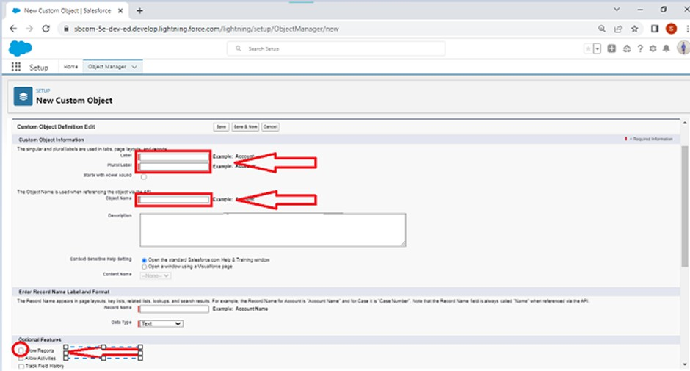

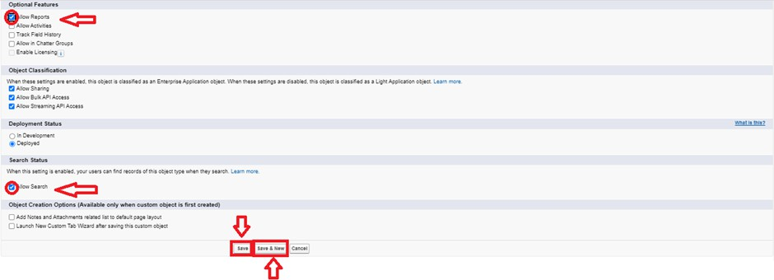

1. ClickonSave.

#### Activity1:CreateCustomerDetailsObject:

Tocreateanobject:

* 1. Fromthesetuppage→ClickonObjectManager→ClickonCreate→Clickon Custom Object.
     1. Enter the label name→ Customer Details
     2. Plural label name→ Customer Details
     3. Enter Record Name Label and Format
        + Record Name → Customer Name
        + DataType→Text
  2. ClickonAllowreportsandTrackFieldHistory,
  3. Allow search → **Save.**

#### Activity2:CreateAppointmentObject:

Tocreateanobject:

1. Fromthesetuppage→ClickonObjectManager→ClickonCreate→Clickon Custom Object.
   1. Enter the label name→ Appointment
   2. Plural label name→ Appointments
   3. Enter Record Name Label and Format
      * Record Name → Appointment Name
      * DataType→AutoNumber
      * Display Format → app-{000}
      * Starting number → 1
2. ClickonAllowreportsandTrackFieldHistory,
3. Allow search → **Save.**

#### Activity3:CreateServicerecordsObject:

Tocreateanobject:

1. Fromthesetuppage→ClickonObjectManager→ClickonCreate→Clickon Custom Object.
2. Enter the label name→ Service records
3. Plural label name→ Service records
4. Enter Record Name Label and Format
   * Record Name → Service records Name
   * DataType→AutoNumber
   * DisplayFormat→ser-{000}
   * Starting number → 1
5. ClickonAllowreportsandTrackFieldHistory,
6. Allow search → **Save.**

#### Activity4:CreateBilling detailsandfeedbackObject:

Tocreateanobject:

1. Fromthesetuppage→ClickonObjectManager→ClickonCreate→Clickon Custom Object.
2. Enter the label name→ Billing details and feedback
3. Plural label name→ Billing details and feedback
4. Enter Record Name Label and Format
   * Record Name → Billing details and feedback Name
   * DataType→AutoNumber
   * Display Format → bill-{000}
   * Starting number → 1
5. ClickonAllowreportsandTrackFieldHistory,
6. Allow search → **Save.**

**Milestone3-Tabs**

**WhatisTab:**Atabislikeauserinterface that is used to build records for objects and to view the records in the objects.

TypesofTabs:

1. **CustomTabs**

Custom object tabs are the user interface for custom applications that you build in salesforce.com. They look and behave like standard salesforce.com tabs such asaccounts, contacts, and opportunities.

1. **WebTabs**

Web Tabs are custom tabs that display web content or applications embedded in the salesforce.com window. Web tabs make it easierforyouruserstoquicklyaccesscontent and applications they frequently use without leaving the salesforce.com application.

1. **VisualforceTabs**

Visualforce Tabs are custom tabs that display a Visualforce page. Visualforce tabs look and behave like standard salesforce.com tabs such as accounts, contacts, and opportunities.

1. **LightningComponentTabs**

Lightning Component tabs allow you to add Lightning components to the navigation menu in Lightning Experience and the mobile app.

1. **LightningPageTabs**

Lightning Page Tabs let you add Lightning Pages to the mobile app navigation menu. Lightning Page tabs don't work like other custom tabs.Oncecreated,theydon'tshowup ontheAllTabspagewhenyouclickthePlusiconthatappearstotherightofyour current tabs. Lightning Page tabs also don't show up in theAvailableTabslistwhenyou customise the tabs for your apps.

#### Activity1:CreatingaCustomTab TocreateaTab:(CustomerDetails)

* 1. Gotosetuppage→typeTabsinQuickFindbar→clickontabs→New (under

custom object tab)

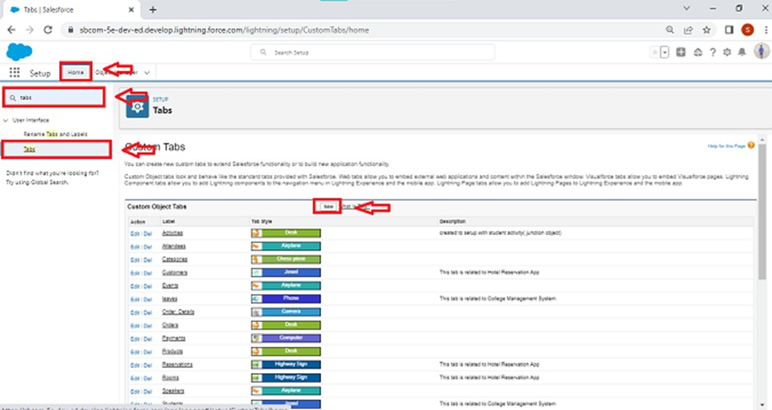

* 1. Select Object(Customer Details) → Select the tab style → Next (Add to profiles page) keep it as default → Next (Add to Custom App)uncheck the include tab .
  2. Make sure that the Append tab to users' existing personal customizations is checked.
  3. Click save.

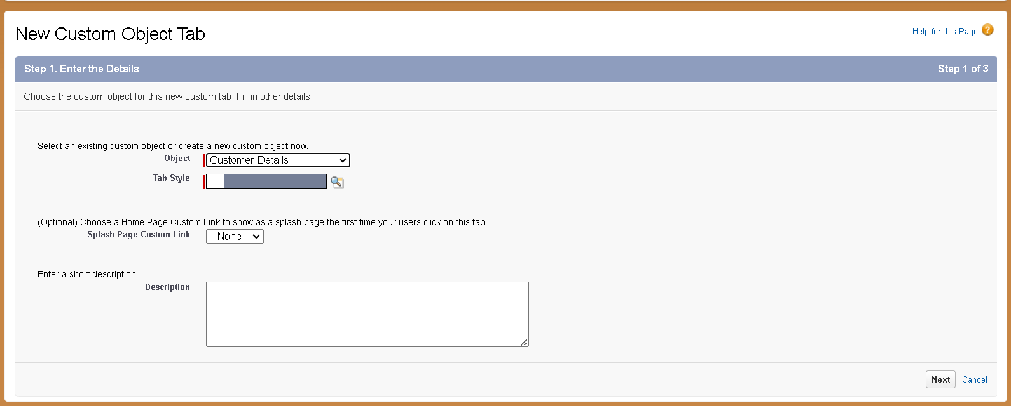

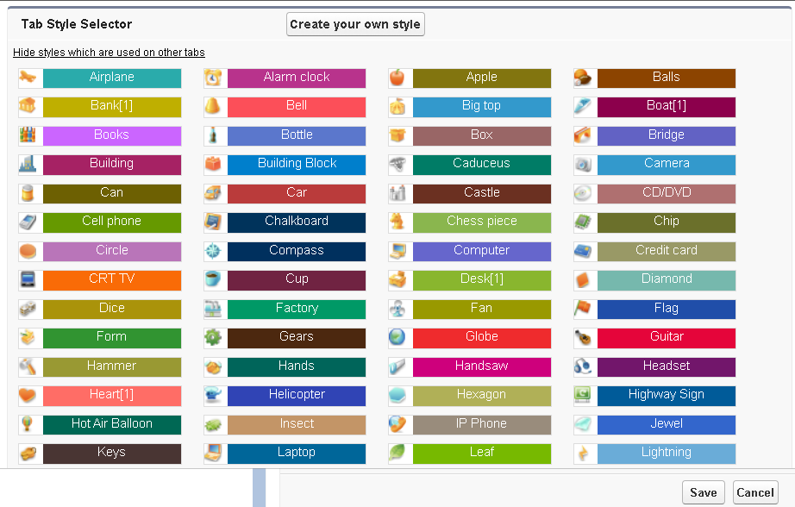

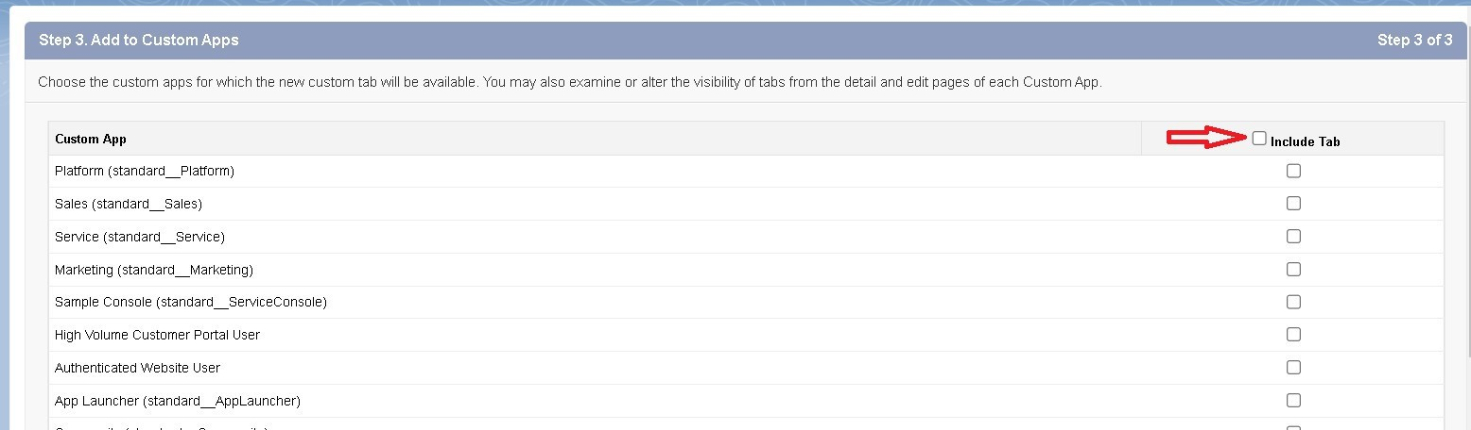

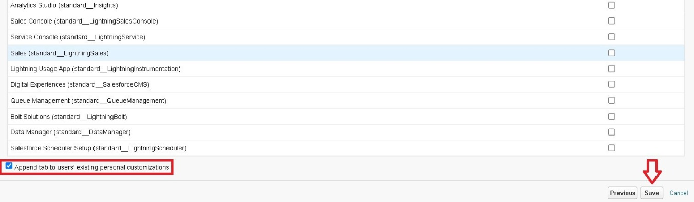

#### Activity2:CreatingRemainingTabs

1. NowcreatetheTabsfortheremainingObjects,theyare“Appointments,Service records,Billing details and feedback”.
2. Follow the same steps as mentioned in Activity -1 .

**Milestone4-TheLightningApp:**

An app is a collection of items that worktogethertoserveaparticularfunction.InLightning Experience, Lightning apps give your users access tosetsofobjects,tabs,andotheritemsall in one convenient bundle in the navigation bar.

Lightning apps let you brand your appswithacustomcolourandlogo.Youcaneveninclude a utility bar and Lightning page tabs in your Lightning app. Members of your org can work more efficiently by easily switching between apps.

#### Activity1:CreateaLightningApp To create a lightning app page:

1. Gotosetuppage→search“appmanager”inquickfind→select“appmanager”→ click on New lightning App.

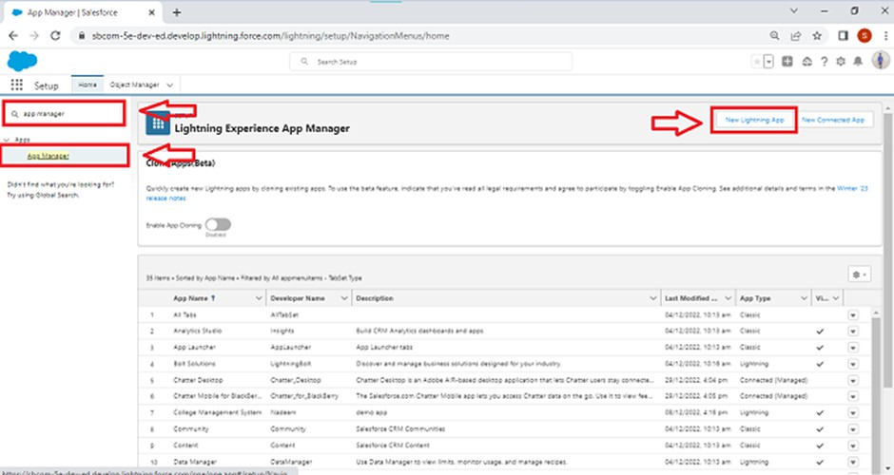

1. 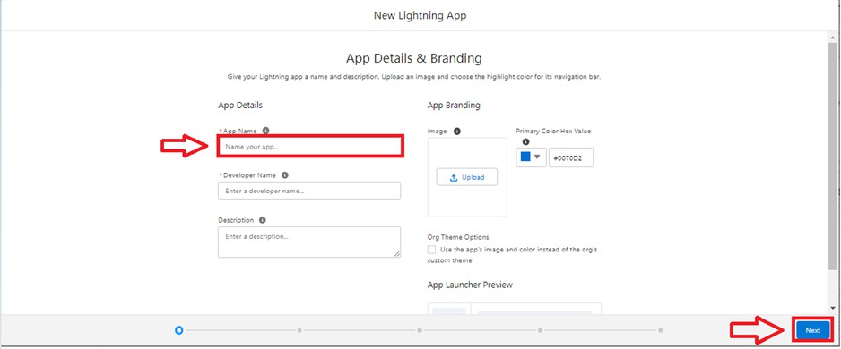Filltheappnameinappdetailsas**GarageManagementApplication**→Next→(App option page) keep it as default → Next → (Utility Items) keep it as default → Next.
2. ToAddNavigationItems:

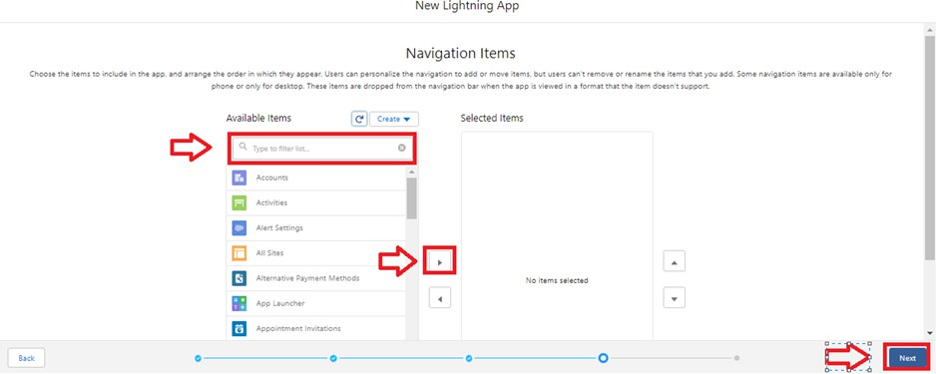

Selecttheitems(CustomerDetails,Appointments,Servicerecords,Billingdetailsand feedback, Reports and Dashboards) from the search bar and move it using the arrow button → Next.

1. ToAddUserProfiles:

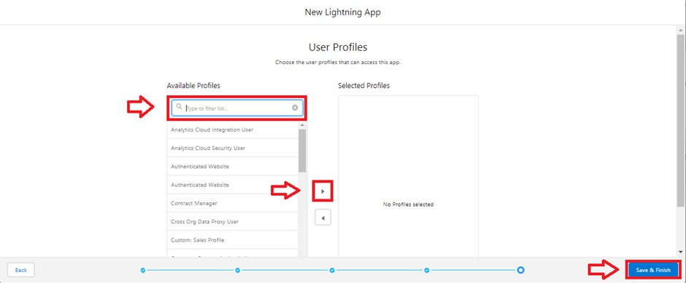

Search profiles (System administrator) in the search bar → click on the arrowbutton→ save & finish.

## Milestone5:Fields

When we talk about Salesforce, Fields represent the data stored in the columns of a relational database. It can also hold any valuable information that you require for a specific object.Hence,theoverallsearching, deletion, and editing of the records become simpler and quicker.

TypesofFields

1. Standard Fields
2. Custom Fields

#### Standard Fields:

As the name suggests, the Standard Fields are the predefined fields in Salesforce that perform a standard task. The main point is that you can’t simply delete a Standard Field until it is a non-required standard field. Otherwise, users have the option to delete them at any point from the application freely. Moreover, we have some fields that you will find common in every Salesforce application. They are,

* + Created By
  + Owner
  + Last Modified
  + Field Made During object Creation

#### Custom Fields:

On the other side of the coin, Custom Fields are highly flexible, and users can change them accordingto requirements. Moreover, each organiser or company can use them if necessary. It means you need not always include them intherecords,unlikeStandardfields.Hence,the final decision depends on the user, and he can add/remove Custom Fields of any given form.

#### Activity1:Creation offields forthe CustomerDetails object

1. **Tocreatefieldsinanobject:**
   1. Gotosetup→clickonObjectManager→typeobjectname(CustomerDetails)insearch bar → click on the object.

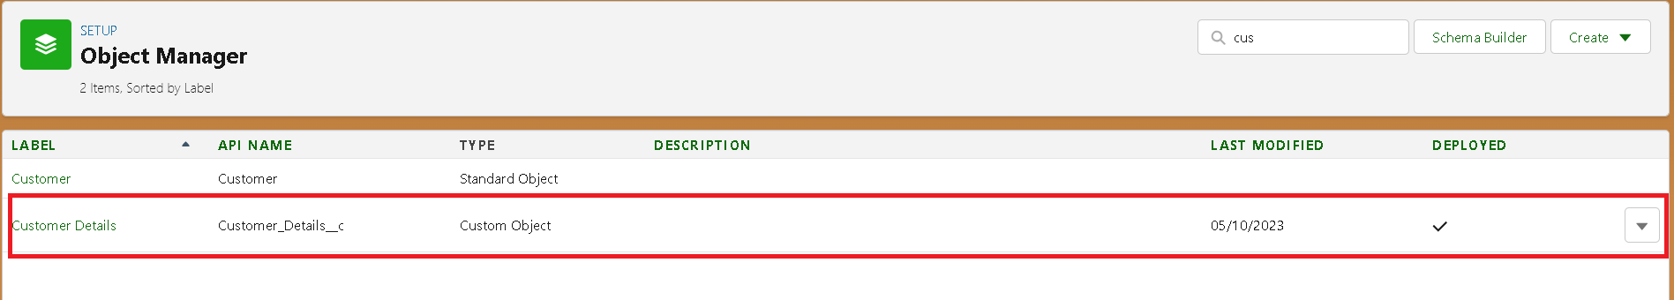

* 1. Now click on “Fields & Relationships” → New

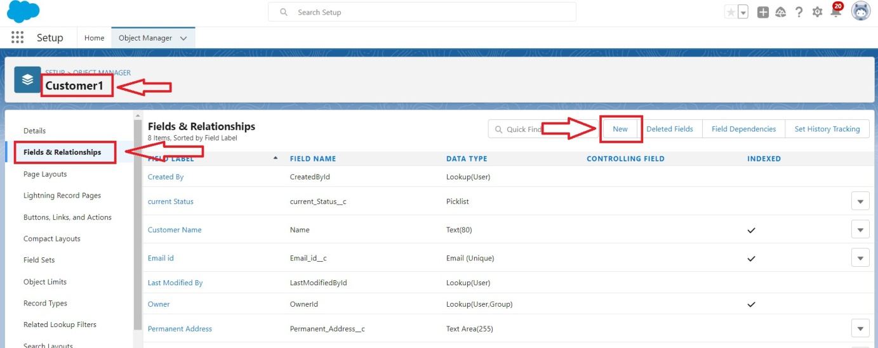

* 1. SelectDataTypeasa“Phone”

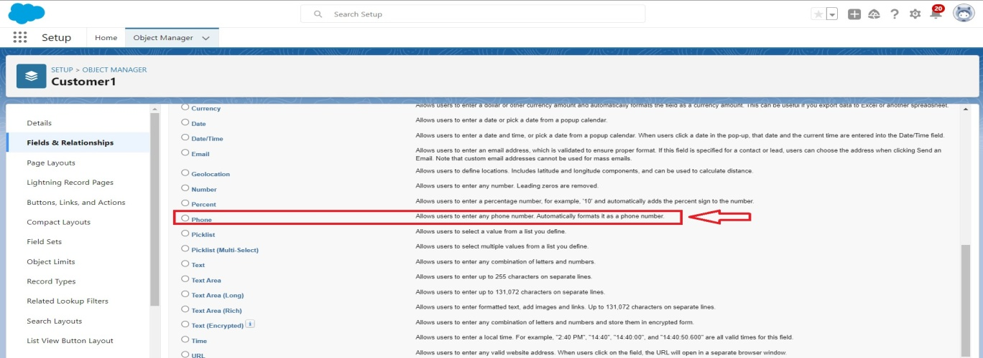

* 1. Click on next.

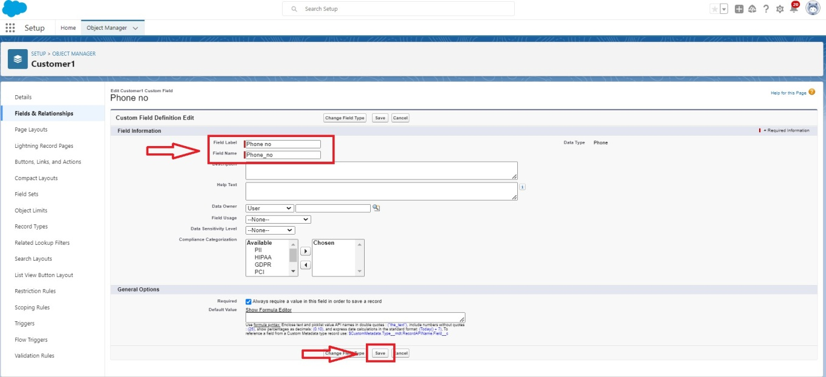

* 1. Fill the Above as following:
     + Field Label: Phone number
     + Field Name : gets auto generated
     + Click on Next → Next → Save and new.

Note: Follow the above steps for the remaining field for the same object.

#### Tocreateanotherfieldsinanobject:

* 1. Gotosetup→clickonObjectManager→typeobjectname(CustomerDetails)insearch bar → click on the object.
  2. Now click on “Fields & Relationships” → New
  3. Select Data type as a “Email” and Click on Next
  4. Fill the Above as following:
     + Field Label : Gmail
     + Field Name : gets auto generated
     + Click on Next → Next → Save and new.

## Activity2:CreationofLookupFields:

#### CreationofLookupField onAppointmentObject :

1. Gotosetup→clickonObjectManager→typeobjectname(Appointment)inthe searchbar → click on the object.

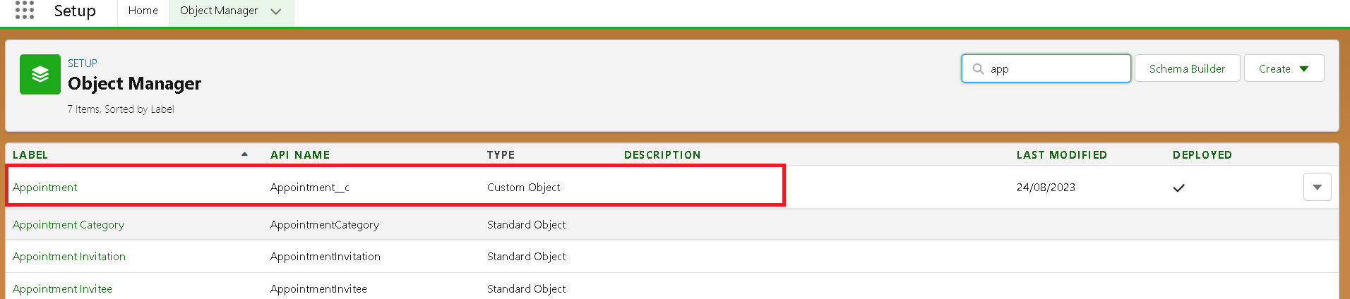

1. Now click on “Fields & Relationships” → New

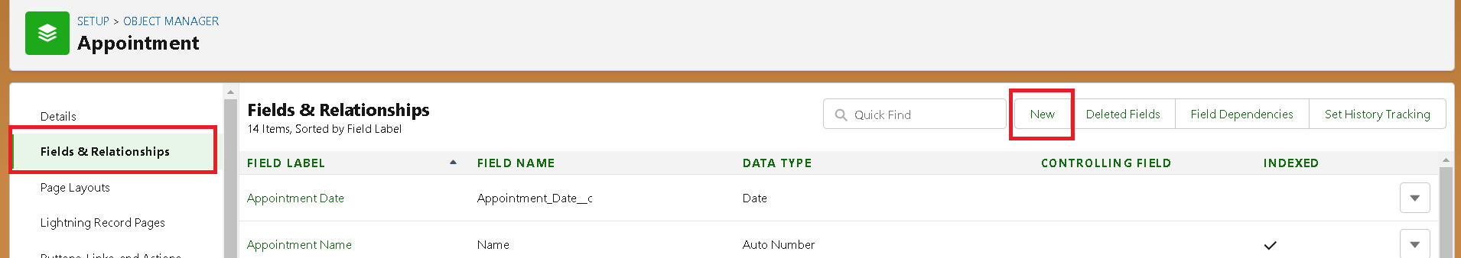

1. Select “Look-up relationship” as data type and click Next.

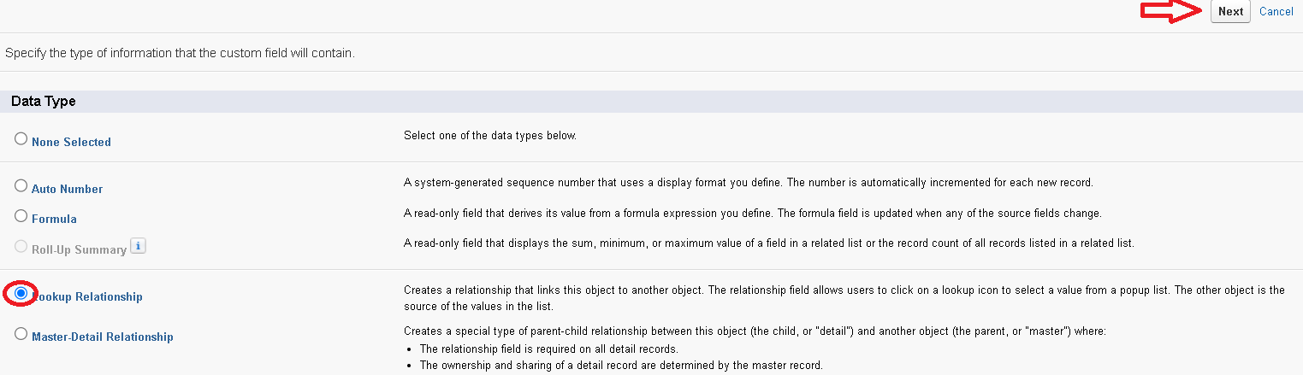

1. Select the related object “ Customer Details” and click next.
2. Next → Next → Save.

#### Note:MakesureyoucompleteActivity4Beforecontinuing. Creation of Lookup Field on Service records Object :

1. Gotosetup→clickonObjectManager→typeobjectname(**Servicerecords**)in search bar → click on the object.
2. Now click on “Fields & Relationships” → New
3. Select “Look-up relationship” as data type and click Next.
4. Selecttherelatedobject“Appointment”andclick next.
5. Make it a required field so click on Required.

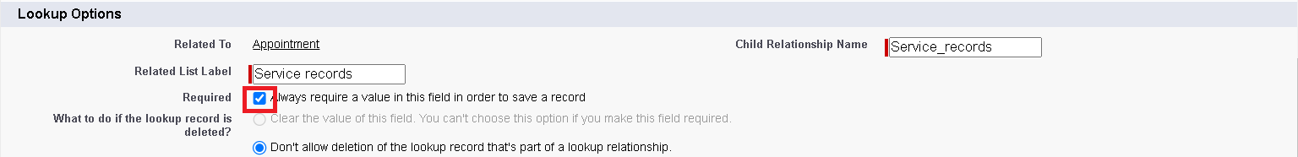

1. Scroll down for Lookup Filter and click on Show filter settings.
2. Now add the filter criteria.
3. Field:Appointment:AppointmentDate→Operator:lessthan→selectfield→ Appointment: Created Date
4. Filter type should be Required.

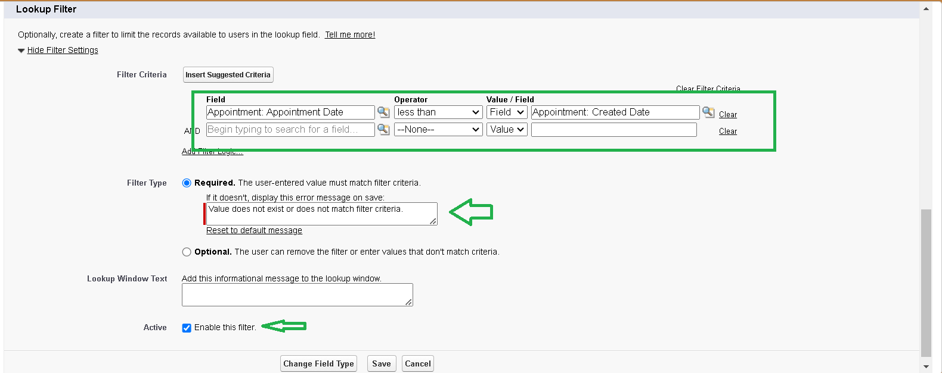

1. ErrorMessage:Valuedoesnotmatchthecriteria.
2. Enable the filter by click on Active.
3. Next → Next → Save.

**CreationofLookupFieldonBillingdetailsandfeedbackObject:**

1. Gotosetup→clickonObjectManager→typeobjectname(**Billingdetailsand feedback** ) in search bar → click on the object.
2. Now click on “Fields & Relationships” → New
3. Select “Look-up relationship” as data type and click Next.
4. Selectthe related object “ **Servicerecords**” andclick next.
5. Next → Next → Save&new.

## Activity3:CreationofCheckboxFields:

#### CreationofCheckbox Fieldon AppointmentObject :

1. Gotosetup→clickonObjectManager→typeobjectname(**Appointment**)in search bar → click on the object.
2. Now click on “Fields & Relationships” → New.
3. Select “Check box” as data type and click Next.

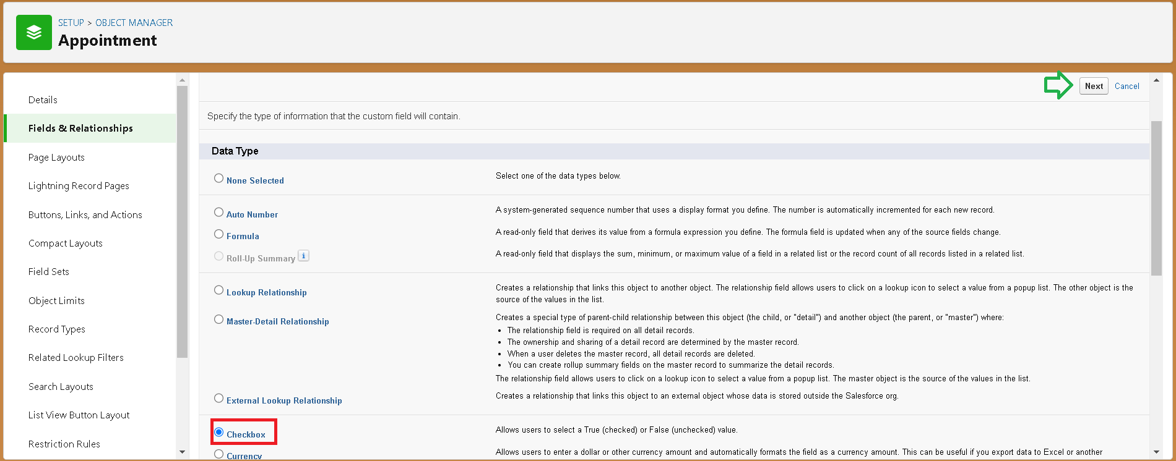

1. Give the Field Label : Maintenance service
2. Field Name : is auto populated
3. Default value : unchecked

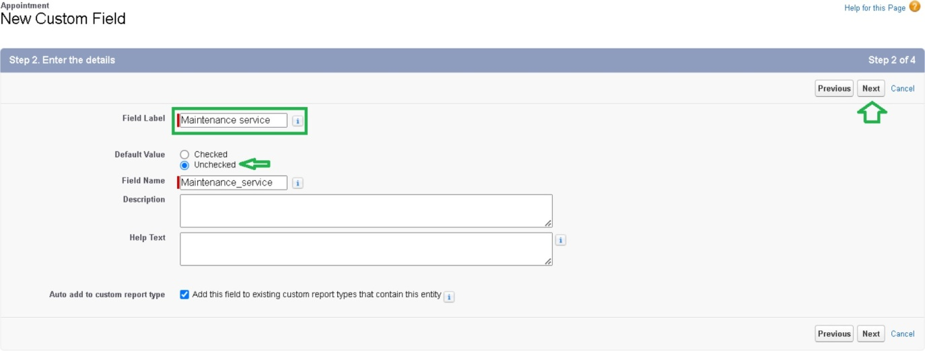

1. Click on next → next → save.

#### CreationofAnother CheckboxFieldson AppointmentObject :

1. Repeat the steps form 1 to 3.
2. Give the Field Label : **Repairs**
3. Field Nme : is auto populated
4. Default value : unchecked
5. Click on next → next → save.
6. Follow the same and create another checkbox with given names
7. Give the Field Label : **Replacement Parts**
8. Field Nme : is auto populated
9. Default value : unchecked
10. Click on next → next → save.

**Creationof Checkbox Field on Service records Object :**

1. Gotosetup→clickonObjectManager→typeobjectname(**Servicerecords**)in search bar → click on the object.
2. Now click on “Fields & Relationships” → New.
3. Select “Check box” as data type and click Next.
4. Give the Field Label : Quality Check Status
5. Field Nme : is auto populated
6. Default value : unchecked
7. Click on next → next → save

#### Activity4:Creationofdate Fields:

**CreationofDateField onAppointmentObject :**

1. Gotosetup→clickonObjectManager→typeobjectname(Appointment)inthe search bar → click on the object.
2. Now click on “Fields & Relationships” → New.
3. Select “Date” as data type and click Next.
4. Give the Field Label : Appointment Date
5. Field Nme : is auto populated
6. Make it as a Required field by clicking on the Required option.
7. Click on next → next → save.

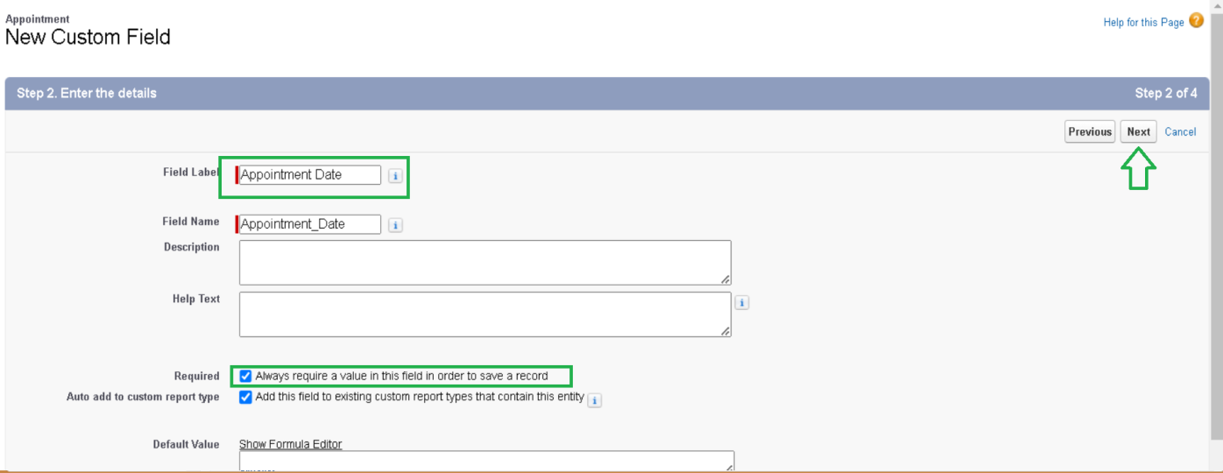

#### Activity5:CreationofCurrencyFields:

**CreationofCurrencyFieldonAppointmentObject:**

1. Gotosetup→clickonObjectManager→typeobjectname(**Appointment**)inthe search bar → click on the object.
2. Now click on “Fields & Relationships” → New.
3. Select “Currency” as data type and click Next.
4. Give the Field Label : Service Amount
5. Field Nme : is auto populated

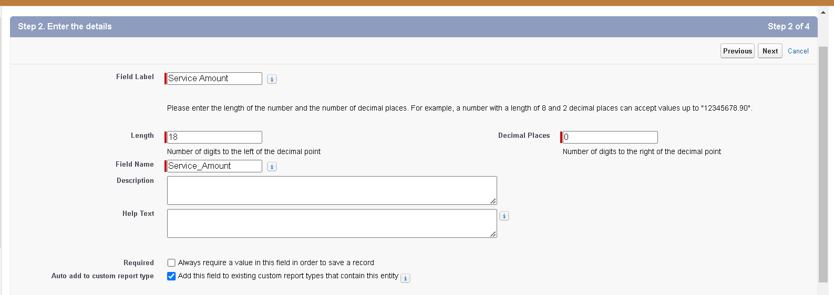

1. Click on next
2. Giveread only for all the profiles in field level security for profile.

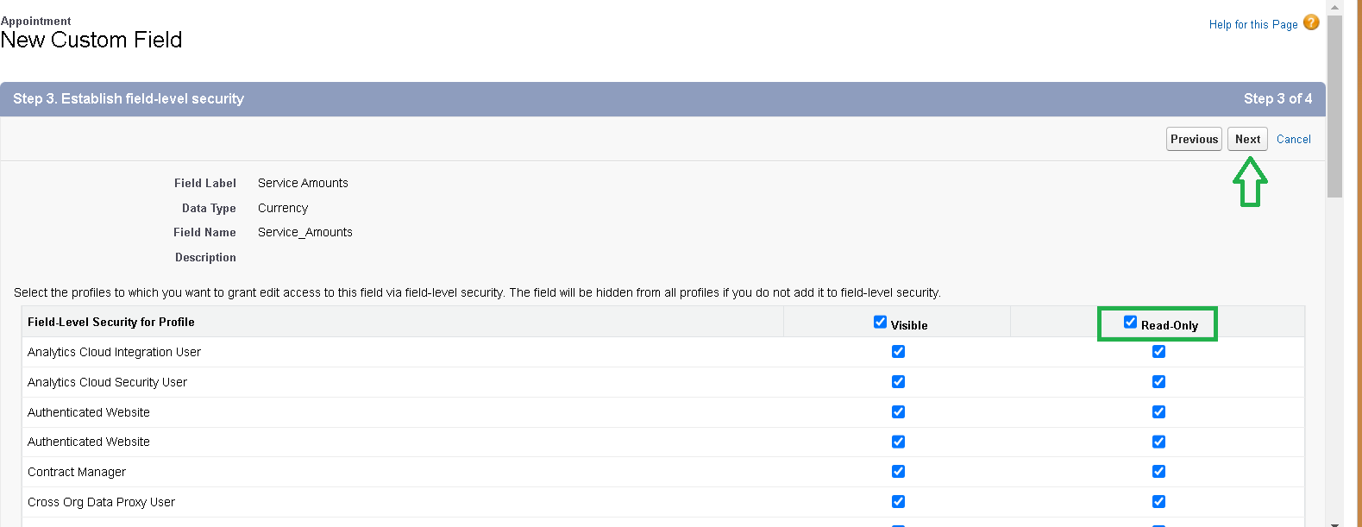

1. Click on next → save.

#### CreationofCurrencyFieldonBillingdetailsandfeedbackObject:

1. Followthesamestepsasmentionedabovein**Billingdetailsandfeedback Object**.
2. Change the label name as mentioned.
3. Give the Field Label : Payment Paid
4. Field Nme : is auto populated

#### Activity6:CreationofTextFields:

1. Gotosetup→clickonObjectManager→typeobjectname(**Appointment**)inthe search bar → click on the object.
2. Now click on “Fields & Relationships” → New.
3. Select“Text”asdatatypeandclick Next.
4. GivetheFieldLabel:Vehiclenumberplate
5. Field Name : is auto populated
6. Length : 10
7. Make the field as Required and Unique.

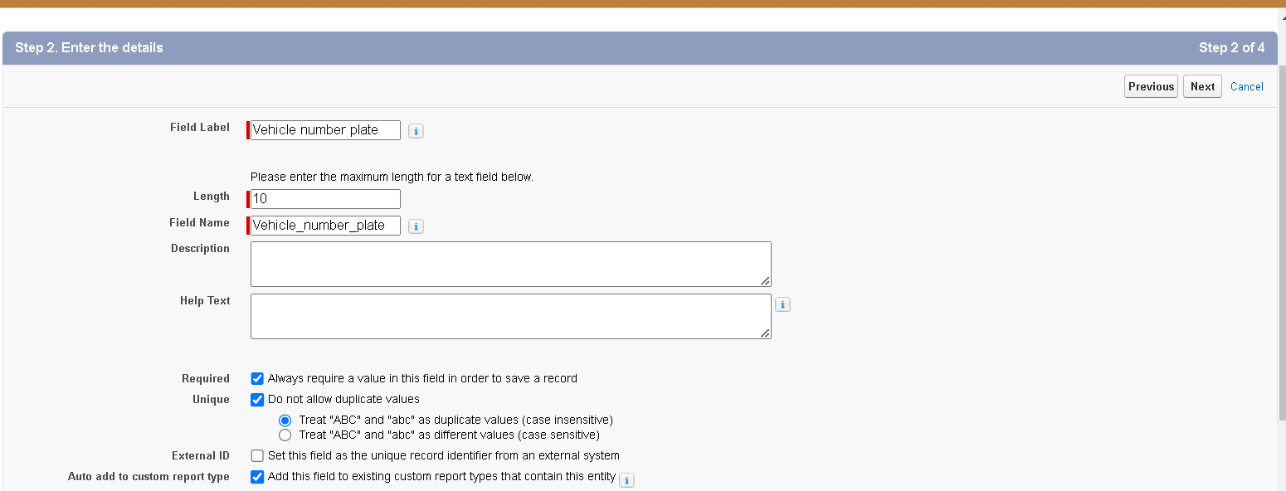

1. Click on next → next → save.

**CreationofTextFieldsinBillingdetailsandfeedbackobject:**

1. Gotosetup→clickonObjectManager→typeobjectname(**Billingdetailsand feedback**) in search bar → click on the object.
2. Now click on “Fields & Relationships” → New.
3. Select “text” as data type and click Next.
4. Give the Field Label : Rating for service
5. Field Name : is auto populated
6. Length : 1
7. Make field as Required .
8. Click on next → next → save

#### Activity7:CreationofPicklist Fields:

**CreationofPicklistFieldsinServicerecordsobject:**

1. Gotosetup→clickonObjectManager→typeobjectname(**Servicerecords**)in search bar → click on the object.
2. Click on fields & relationship → click on New.
3. Select Data type as “Picklist” and click Next.
4. EnterFieldLabelas“ServiceStatus”,undervaluesselect“Entervalues,witheach value separated by a new line" and enter values as shown below.
5. The values are:Started, Completed.

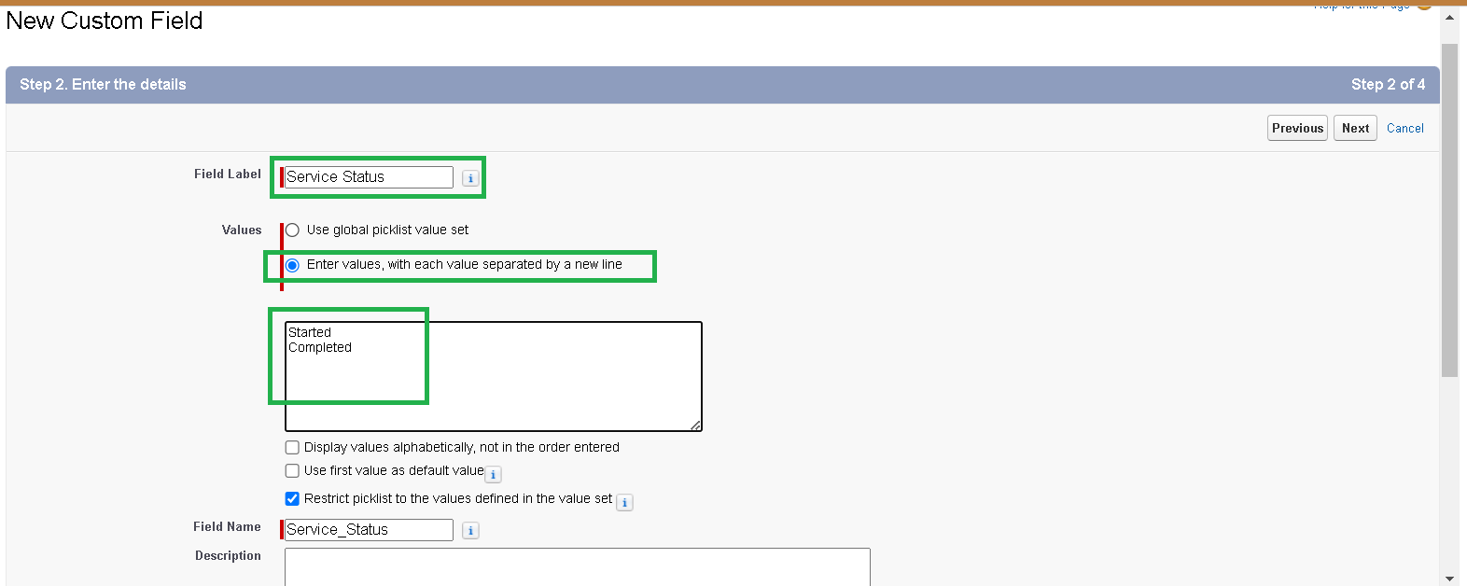

1. Click Next.
2. Next → Next → Save.

**CreationofPicklistFieldsinBillingdetailsandfeedbackobject:**

1. Gotosetup→clickonObjectManager→typeobjectname(**Billingdetailsand feedback**) in search bar → click on the object.
2. Click on fields & relationship → click on New.
3. Select Data type as “Picklist” and click Next.
4. Enter Field Label as “Payment Status”, under values select “Enter values, with eachvalue separated by a new line" and enter values as shown below.
5. The values are:Pending, Completed.
6. Click Next.
7. Next → Next → Save.

## Activity8:CreatingFormulaFieldinServicerecordsObject

1. Gotosetup→clickonObjectManager→typeobjectname(Servicerecords)in search bar → click on the object.
2. Click on fields & relationship → click on New.
3. Select Data type as “Formula” and click Next.
4. Give Field Label and Field Name as “service date” and select formula return type as “Date” and click next.

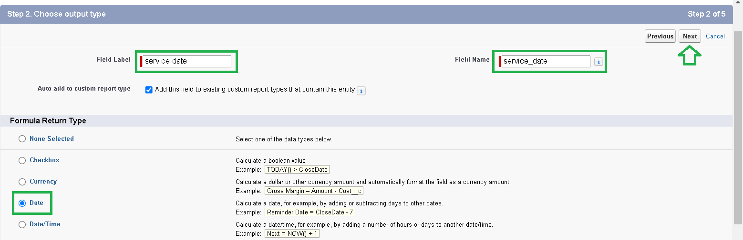

1. Insert field formula should be : CreatedDate

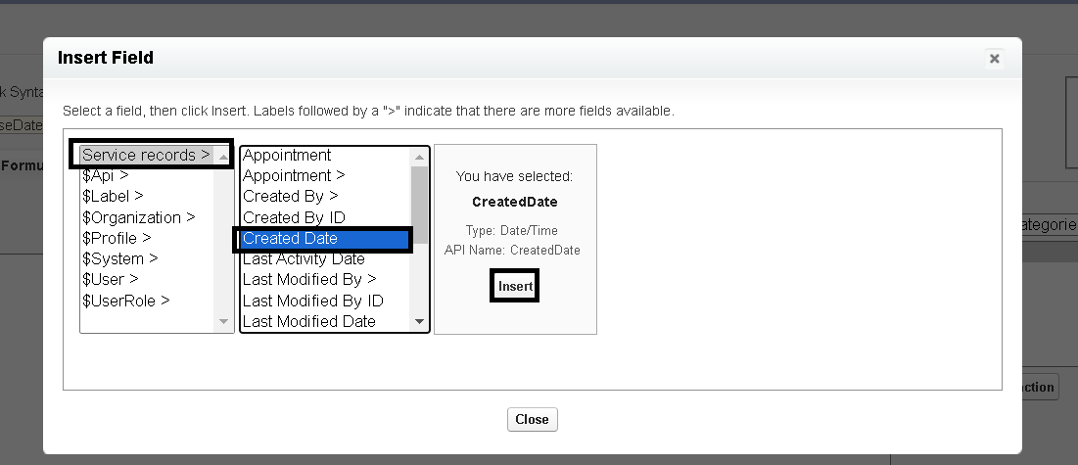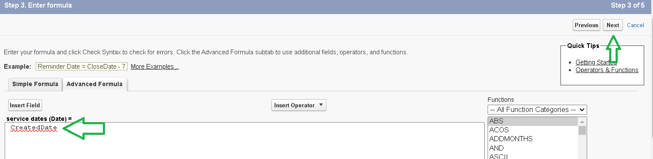

1. click “Check Syntax” .
2. Click next → next → Save.

# Milestone6:Validationrule

Validation rules are applied when a user tries to save a record and are used to check if thedata meets specified criteria. If the criteria are not met, the validation rule triggers an error message and prevents the user from saving the record until the issues are resolved.

## Activity1:TocreateavalidationruletoanAppointmentObject

1. Gotothesetuppage→clickonobjectmanager→Fromdropdownclickeditfor

**Appointment** object.

1. Click on the validation rule → click New.

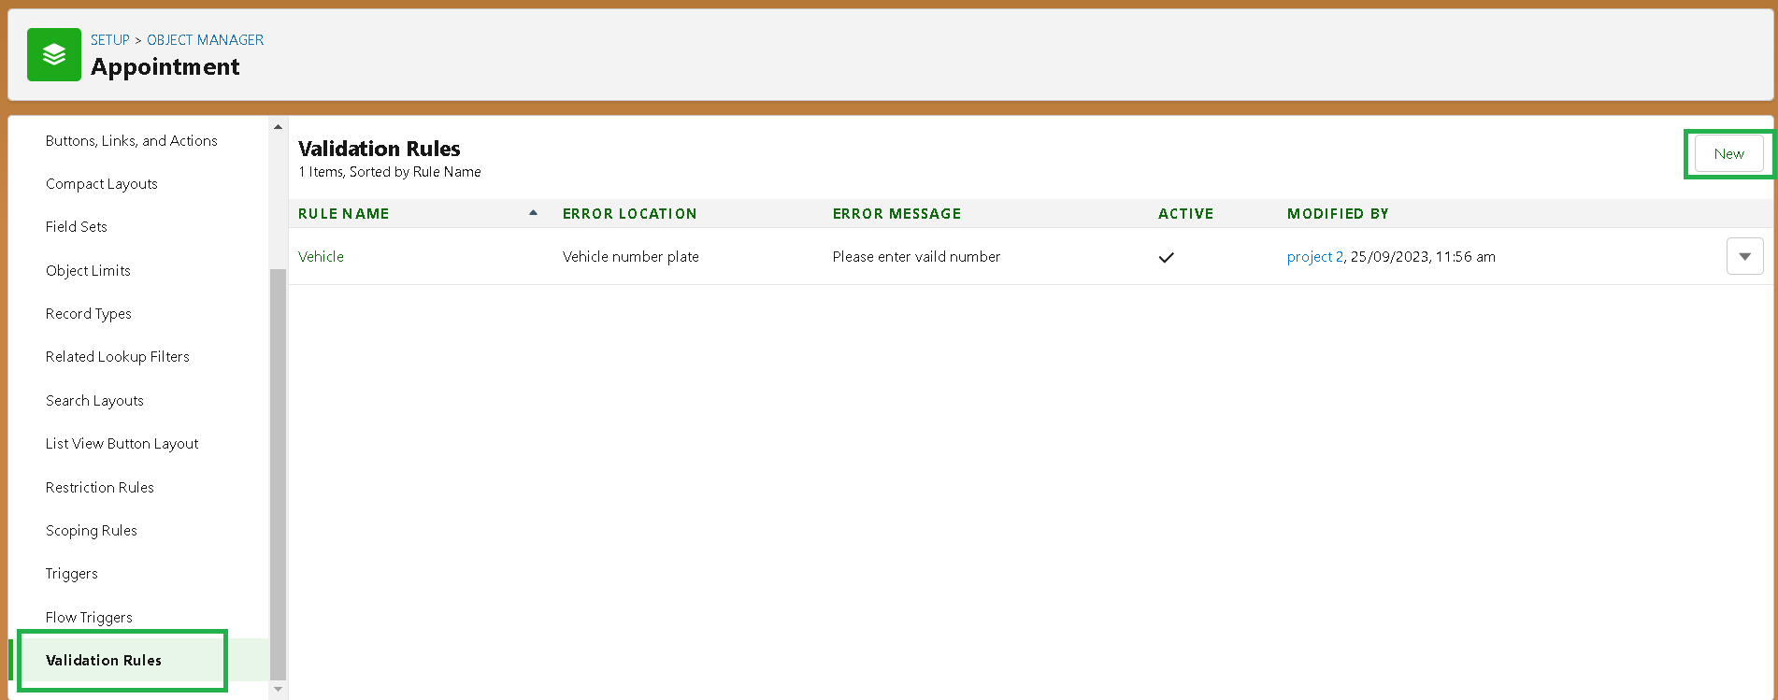

1. EntertheRulenameas“Vehicle”.
2. Insert the Error Condition Formula as : -

NOT(REGEX(Vehicle_number_platec,"[A-Z]{2}[0-9]{2}[A-Z]{2}[0-9]{4}"))

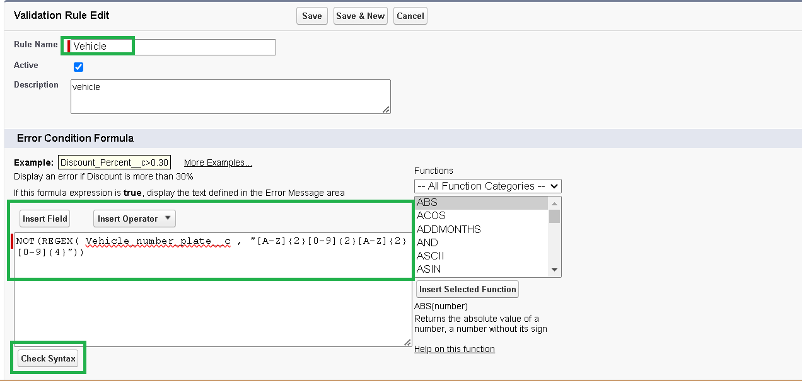

1. Enter the Error Message as “Please enter vaild number ”, select the Error locationas Field and select the field as “Vehicle number plate”, and click Save.

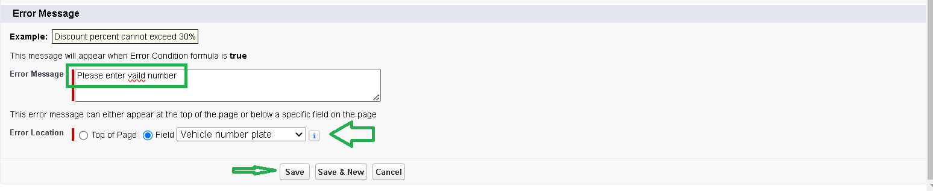

## Activity2:TocreateavalidationruletoanBillingdetailsand feedback Object

1. Gotothesetuppage→clickonobjectmanager→Fromdropdownclickeditfor

#### Billing details and feedback object.

1. Click on the validation rule → click New.
2. Enter the Rule name as “ rating_should_be_less_than_5”.
3. Insert the Error Condition Formula as : -

NOT( REGEX( Rating_for_servicec , "[1-5]{1}"))

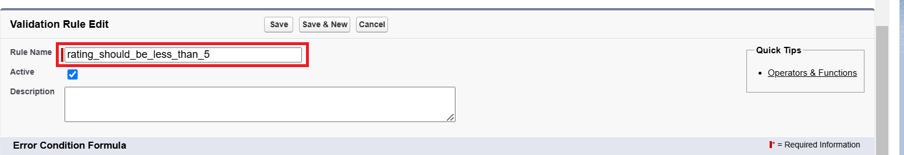

1. Enter the Error Message as“ratingshouldbefrom1to5”,selecttheErrorlocationas Field and select the field as “Rating for Service”, and click Save.

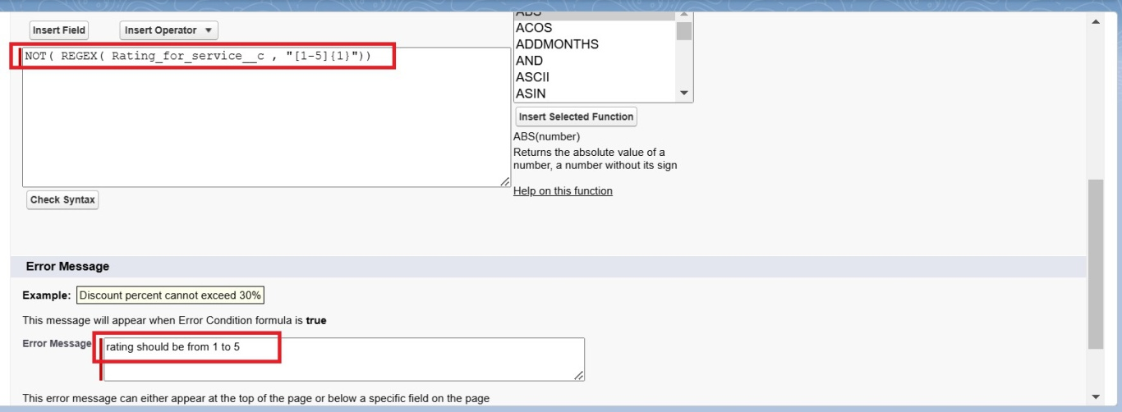

# Milestone7:Duplicaterule

## Activity1:TocreateamatchingruletoanCustomerdetailsObject

1. Go to quick find box in setup and search for **matching Rule.**
2. Click on matching rule → click on New Rule.

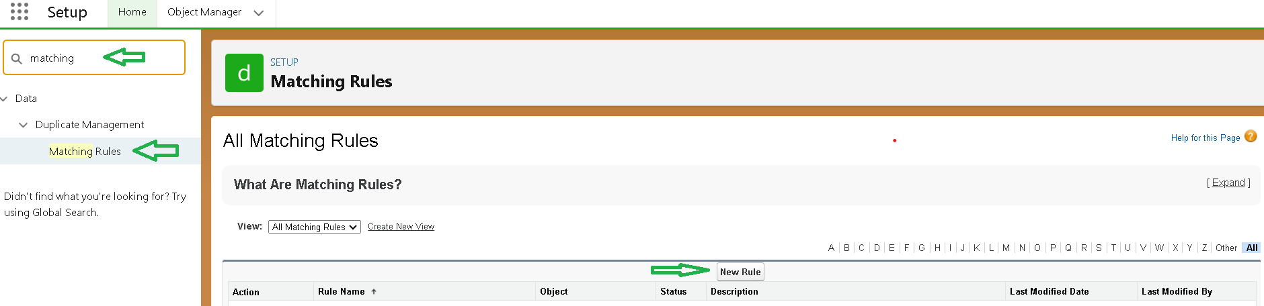

1. Select the object as Customer details and click Next.

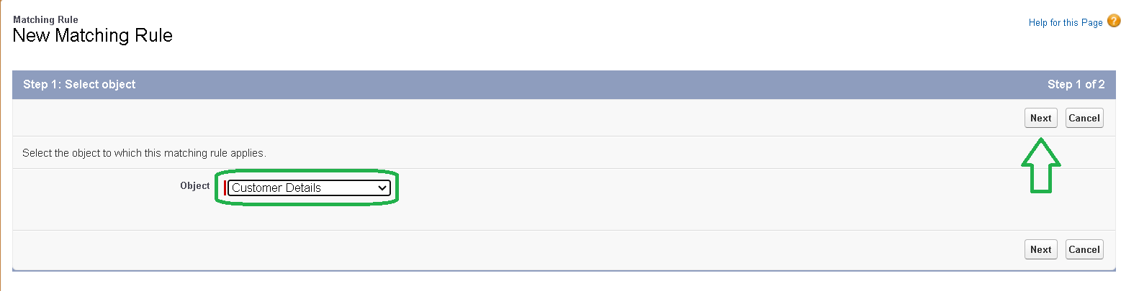

1. Give the Rule name : Matching customer details
2. Unique name : is auto populated
3. Define the matching criteria as
4. Field Matching Method
   1. Gmail Exact
   2. Phone Number Exact
5. Click save.
6. After Saving Click on Activate.

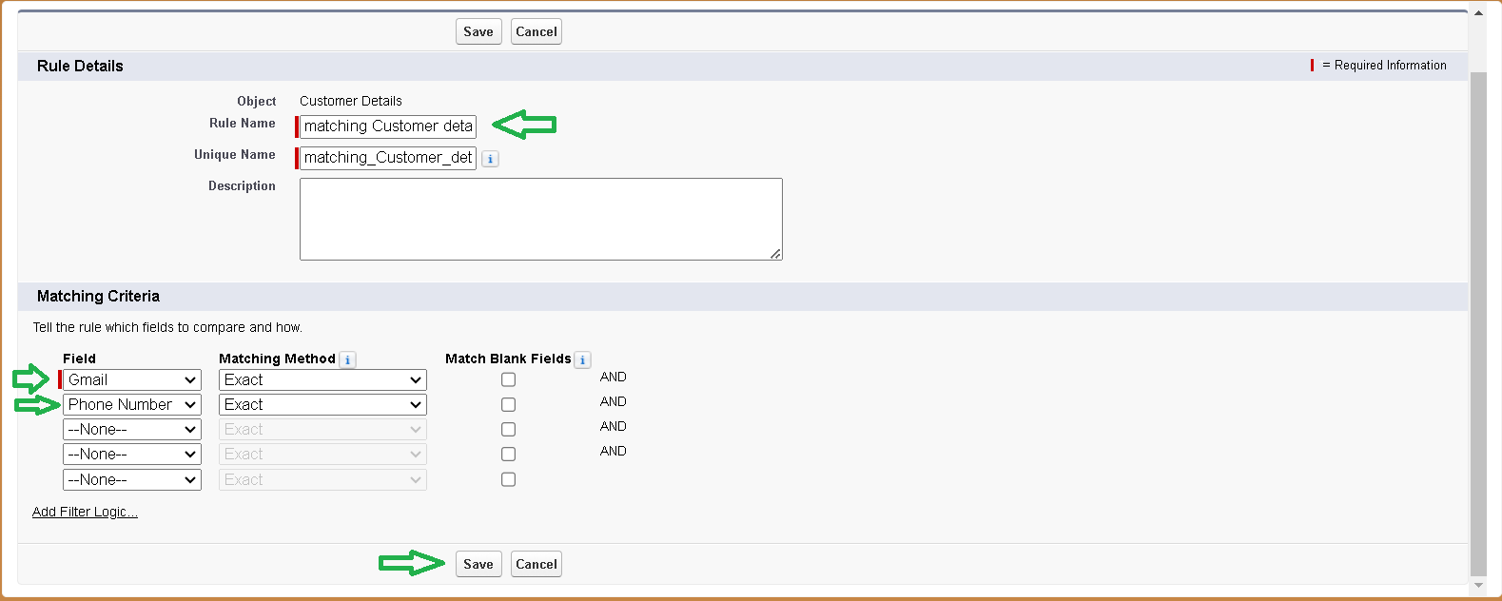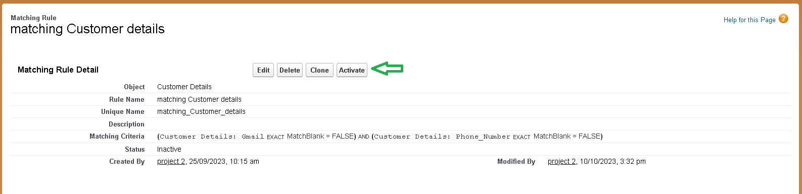

## Activity2:TocreateaDuplicateruletoanCustomerdetailsObject

1. Go to quick find box in setup and search for **Duplicate rules.**
2. Click on Duplicate rule → click on New Rule → select customer details object.

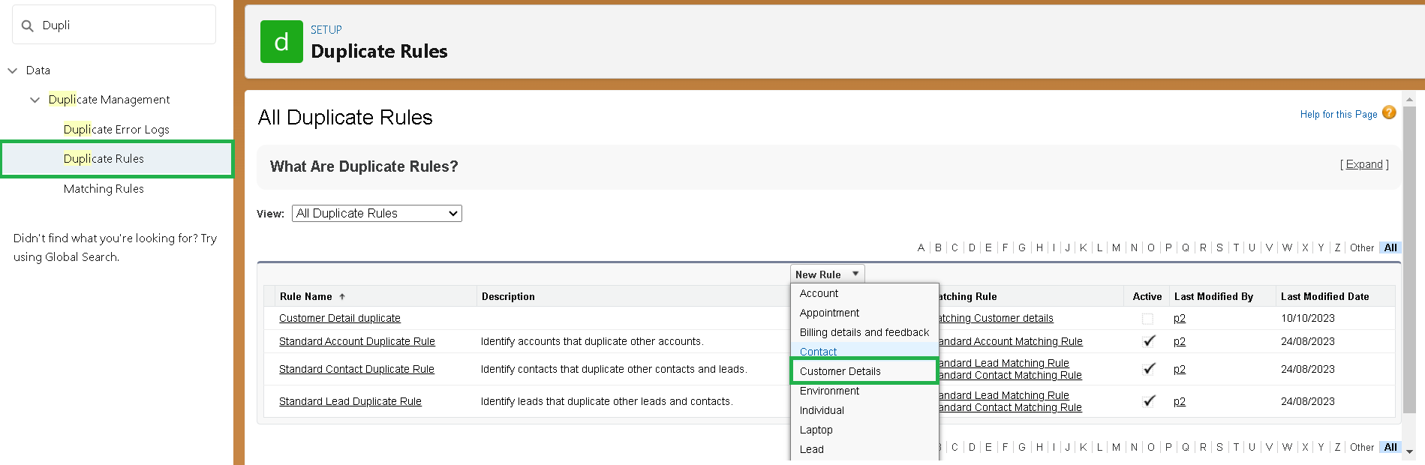

1. Give the Rule name as : Customer Detail duplicate
2. Scroll a little in Matching rule section
3. Select the matching rule:Matching customer details
4. And Click on save.
5. After saving the Duplicate Rule, Click on Activate.

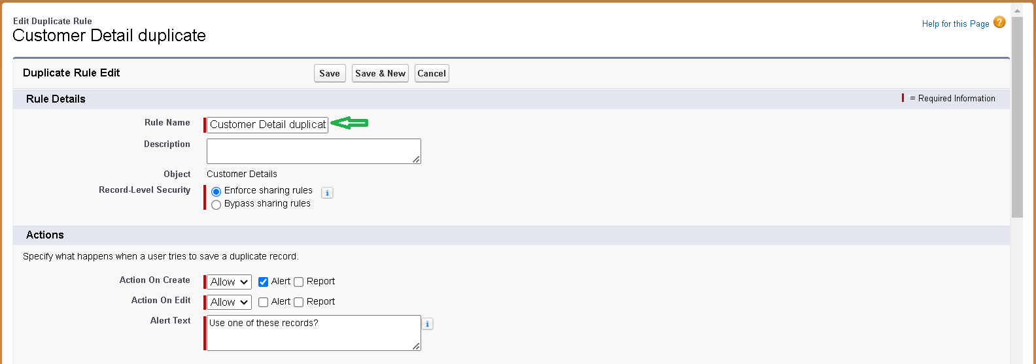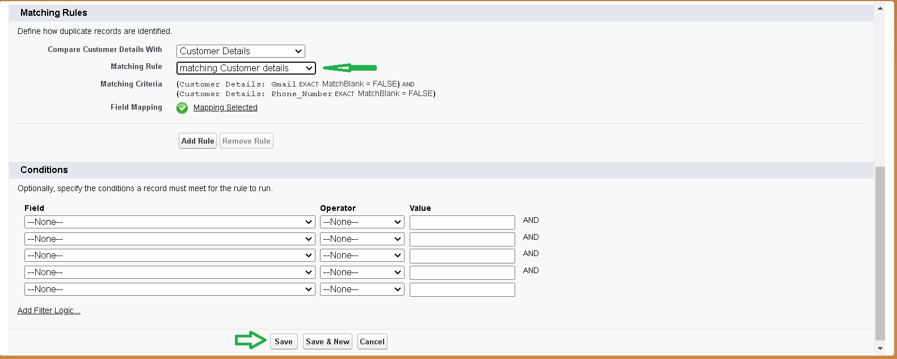

## Milestone8:Profiles

A profile is a group/collection of settings and permissions that define what a user can do in salesforce. Profile controls “Object permissions, Field permissions, User permissions, Tab settings, App settings, Apex class access, Visualforce page access, Page layouts, Record Types, Login hours & Login IPranges.Youcandefineprofilesbytheuser'sjobfunction.For example System Administrator, Developer, Sales Representative.

## Typesofprofilesinsalesforce

#### Standard profiles:

By default salesforce provides below standard profiles.

* + Contract Manager
  + Read Only
  + Marketing User
  + Solutions Manager
  + Standard User
  + System Administrator.

Wecannotdeletedstandardones

Eachofthese standard ones includes a default set of permissions for all of the standard objects available on the platform.

#### Custom Profiles:

Custom ones defined by us.

They can be deleted if there are no users assigned with that particular one.

## Activity1:ManagerProfile

#### Tocreateanewprofile:

1. Gotosetup→typeprofilesinquickfindbox→clickonprofiles→clonethedesired profile (Standard User) → enter profile name (Manager) → Save.

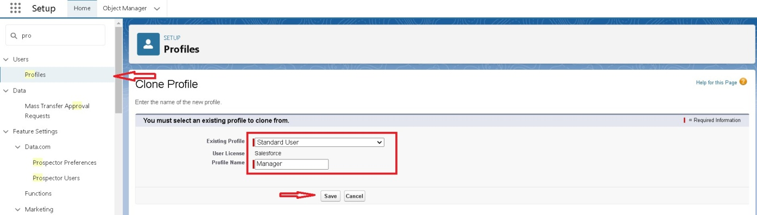

1. While still on the profile page, then click Edit.

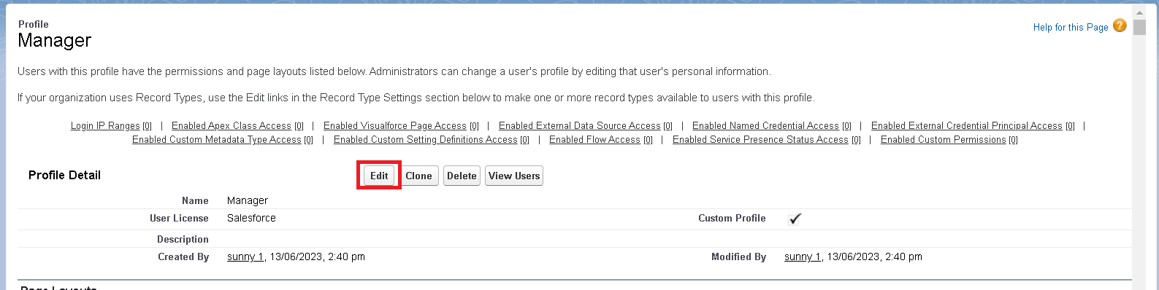

1. Select the Custom App settings as default for the Garage management.

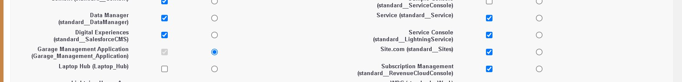

1. Scroll down to Custom Object Permissions and Give access permissions for Appointments,Billingdetailsandfeedback,servicerecordsandcustomerdetailsobjects as mentioned in the below diagram.

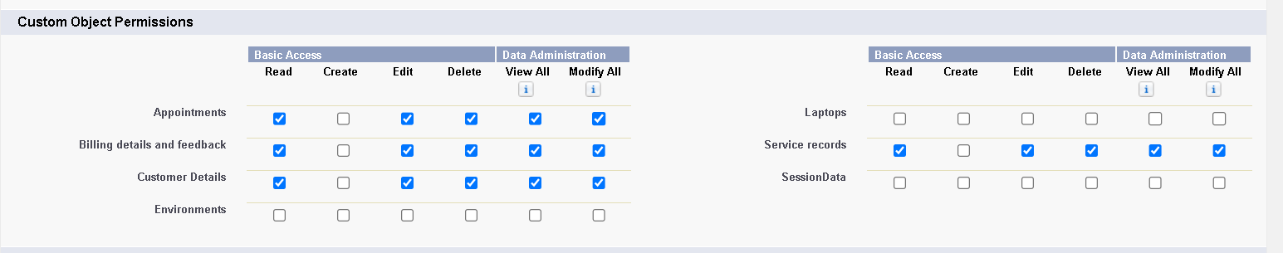

1. Changing the session times out after should be “ 8 hours of inactivity”.
2. Change the password policies as mentioned :
3. User passwords expire in should be “ never expires ”.
4. Minimum password length should be “ 8 ”, and click save.

## Activity2:salespersonProfile

1. Gotosetup→typeprofilesinquickfindbox→clickonprofiles→clonethedesired profile (Salesforce Platform User) → enter profile name (sales person) → Save.
2. While still on the profile page, then click Edit.
3. Select the Custom App settings as default for the GArage management.
4. Scroll down to Custom Object Permissions and Give access permissions for Appointments,Billingdetailsandfeedback,servicerecordsandcustomerdetailsobjects as mentioned in the below diagram.

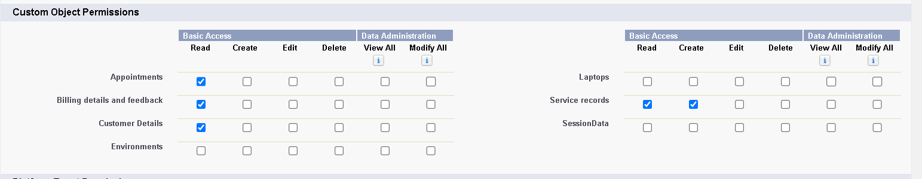

1. And click save.

## Milestone9:Role&RoleHierarchy

A role in Salesforcedefinesauser'svisibilityaccessattherecordlevel.Rolesmaybeusedto specify the types of access that people in your Salesforce organization can have to data. Simply put, it describes what a user could see within the Salesforce organization.

## Activity1:CreatingManagerRole

Creating Manager Role:

1. Go to quick find → Search for Roles → click on set up roles.

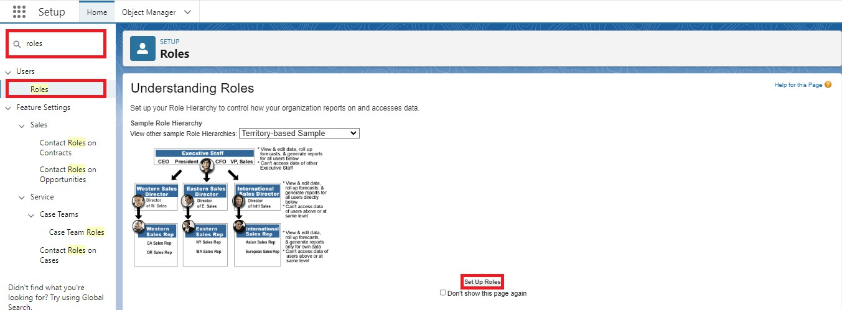

1. Click on Expand All and click on add role under whom this role works.

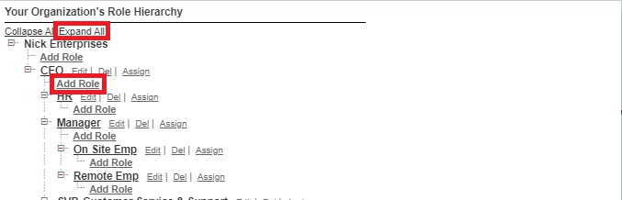

1. Give Label as “Manager” and Role name gets auto populated. Then click on Save.

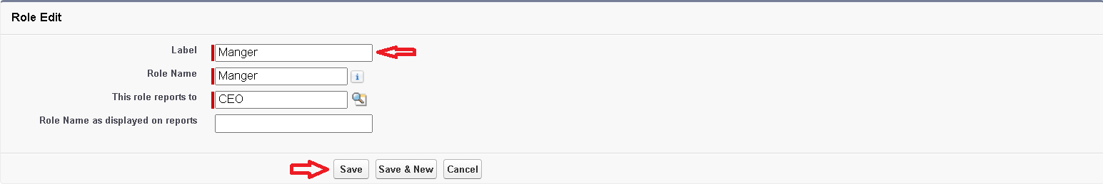

## Activity2:Creatinganotherroles

Creating another two roles under manager

1. Go to quick find → Search for Roles → click on set up roles.
2. Clickplus on CEO role, and click add role under manager.

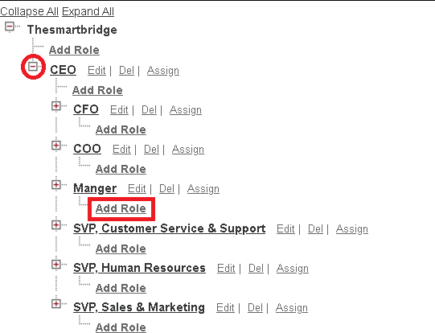

1. Give Label as “sales person” and Role name gets auto populated. Then click on Save.

## Milestone10:Users

A user is anyone who logs in to Salesforce. Users are employees at your company, such as sales reps, managers, and IT specialists, who need access to the company's records. Every user in Salesforce has a user account. The user account identifies the user, and the user account settings determine what features and records the user can access.

## Activity1:CreateUser

1. Goto setup → type users in quick find box → select users → click New user.
2. Fill in the fields
   1. First Name : Niklaus
   2. Last Name : Mikaelson
   3. Alias :Give a Alias Name
   4. Email id : Give your Personal Email id
   5. Username :Username should be in this form: [text@text.text](mailto:text@text.text)
   6. Nick Name : Give a Nickname
   7. Role : Manager
   8. Userlicence: Salesforce
   9. Profiles : Manager

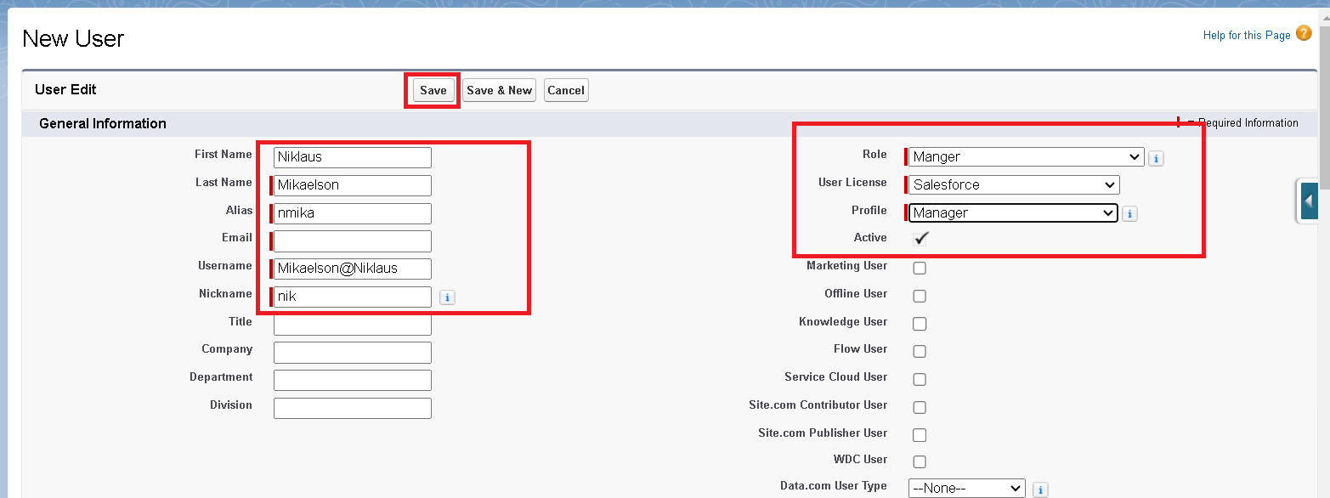

1. Save.

## Activity2:creatinganotherusers

* 1. Repeat the steps and create another user using
     1. Role :sales person
     2. User licence : Salesforce Platform
     3. Profile :sales person

**Note:create atleast3users withthese permissions.**

### Milestone11:Publicgroups

Public groups are a valuable tool for Salesforce administrators and developers to streamline user management, data access, and security settings. By creating and using public groups effectively,youcanmaintainasecureandorganizedSalesforceenvironmentwhileensuring that users have appropriate access to the resources they need.

## Activity1:CreatingNewPublicGroup

1. Go to setup → type users in quick find box → select public groups→ click New.

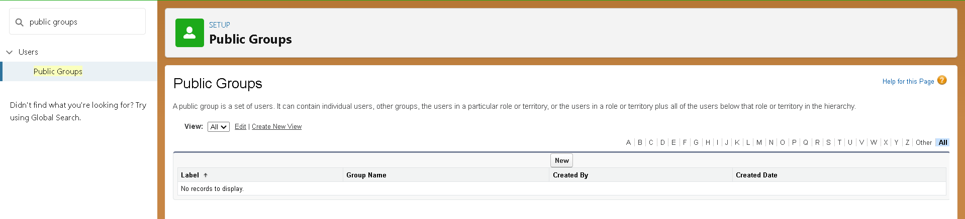

1. Give the Label as “sales team”.
2. Group name is autopopulated.
3. Search for Roles.
4. InAvailableMembersselectSalespersonandclickonadditwillbemovedto selected member.
5. Click on save.

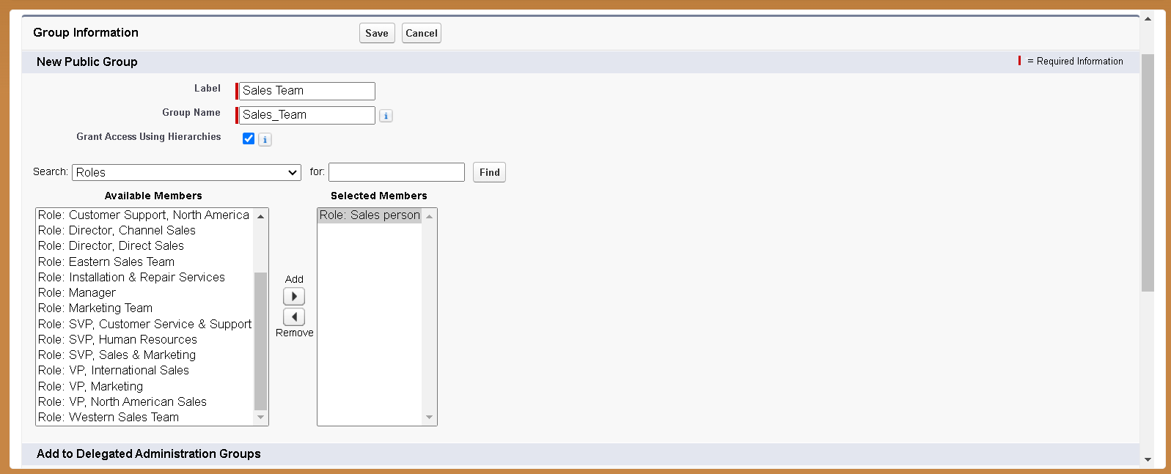

### Milestone12:SharingSetting

Salesforce allows you to configure sharing settings to control how records are accessed and shared within your organization. These settings are crucial for maintaining data security and privacy.Salesforceprovidesavarietyoftoolsandmechanismstodefineandenforcesharing rules, such as:

#### Organization-WideDefault(OWD)Settings:

These settings define the default level of access for all objects within your Salesforce org.

OWDsettingsincludePrivate,PublicRead-Only,PublicRead/Write,andControlledby Parent.

OWD settings can be configured for each standard and custom object.

#### Role Hierarchy:

Salesforce uses a role hierarchy to determine record access.

Usersathigherlevelsinthehierarchyhavegreateraccesstorecordsownedbyorsharedwith users lower in the hierarchy.

TherolehierarchyisoftenusedincombinationwithOWDsettingstograntdifferentlevels of access.

#### ProfilesandPermissionSets:

Profilesandpermissionsetsallowadministratorstospecifyobject-levelandfield-level permissions for users.

Profilesaretypicallyusedtograntgeneralobjectandfieldaccess,whilepermissionsetscan be used to extend those permissions to specific users.

#### Sharing Rules:

Sharing rules are used to extend access to records for users who meet specific criteria. Theycanbeusedtograntread-onlyorread-writeaccesstorecordsownedbyotherusers. Manual Sharing:

Administratorsandrecordownerscanmanuallysharespecificrecordswithotherusersor groups.

## Activity1:CreatingSharingsettings

1. Go to setup → type users in quick find box → select Sharing Settings→ click Edit.
2. ChangetheOWDsettingoftheServicerecordsObjecttoprivateasshownin fig.

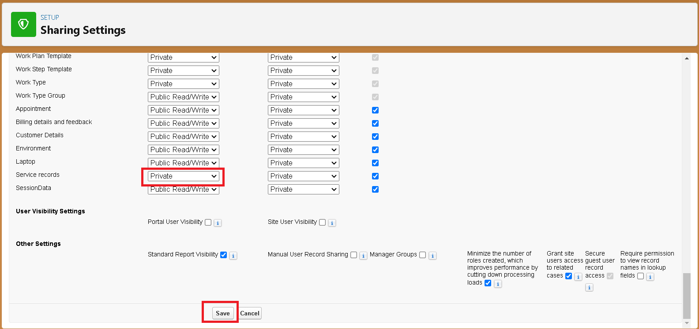

1. Clickonsaveandrefresh.
2. Scrolldownabit,ClicknewonServicerecordssharingRules. 5.
3. GivetheLabelnameas“Sharingsetting”
4. Rulenameisautopopulated.
5. Instep3:Selectwhichrecordstobeshared,membersof“Roles”>>“Sales person”
6. Instep4:sharewith,select“Roles”>>“Manager”
7. Instep5:Changetheaccesslevelto“Read/write”.
8. Clickonsave.

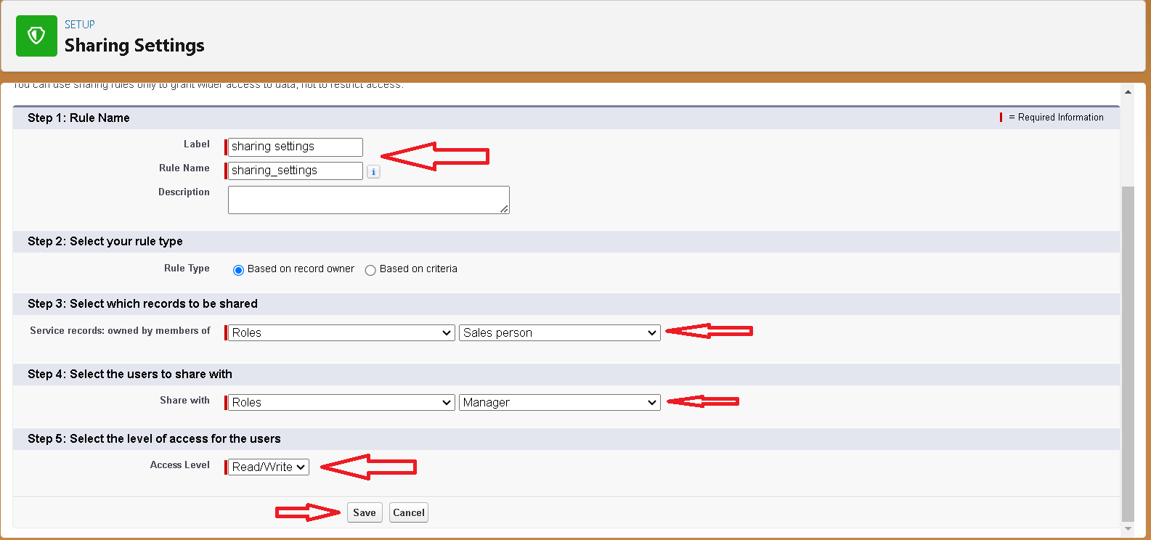

### Milestone13:Flows

In Salesforce, a flow is a powerful tool that allows you to automate business processes,collect and update data, and guide users through a series of screens or steps. Flows are built using a visual interface and can be created without any coding knowledge.

## Activity1:CreateaFlow

1. 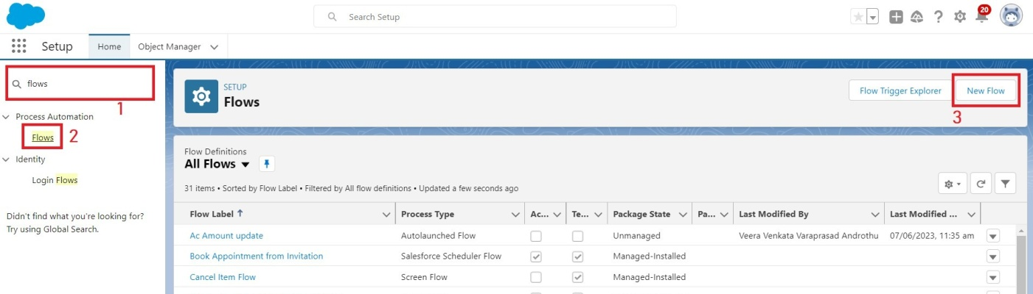Go to setup → type Flow in quick find box →ClickontheFlowandSelecttheNew Flow.
2. Select the Record-triggered flow and Click on Create.

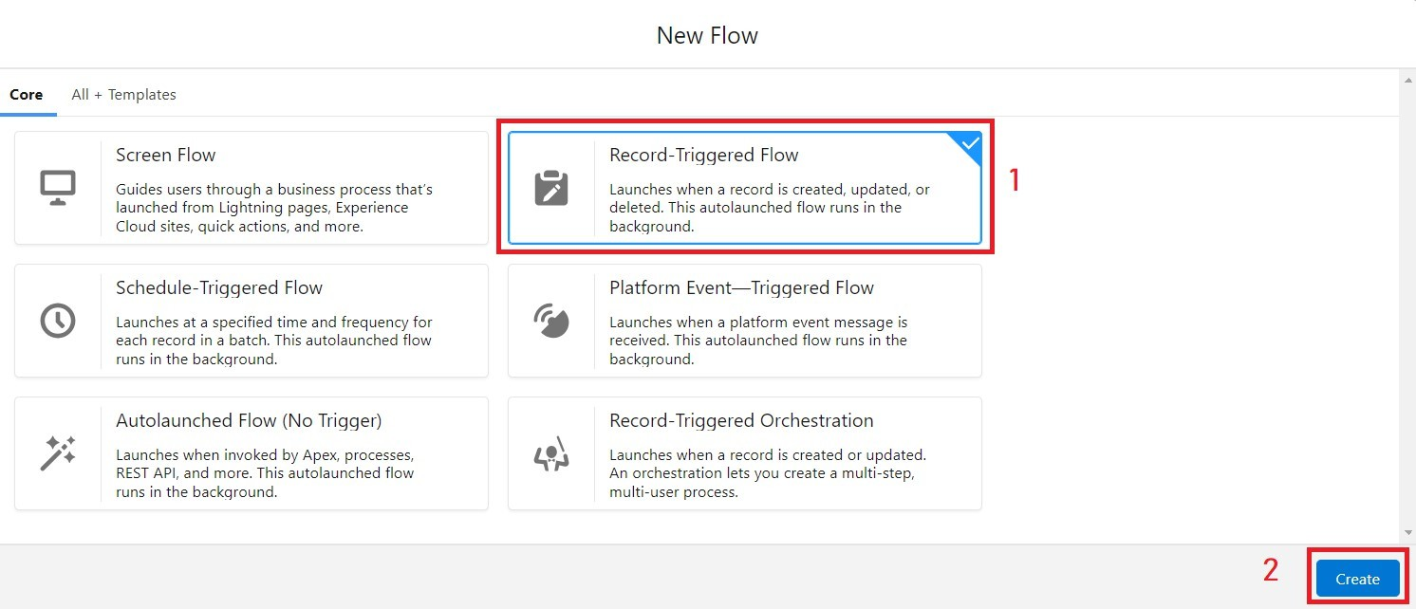

1. Select the Object as “Billing details and feedback”in the Drop down list.
2. SelecttheTriggerFlowwhen:“ArecordisCreatedor Updated”.
3. Select the Optimize the flow for: “Actions and Related Records” and Click on Done.

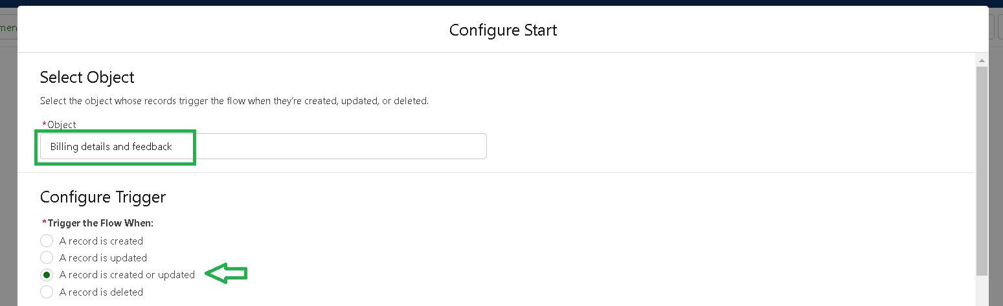

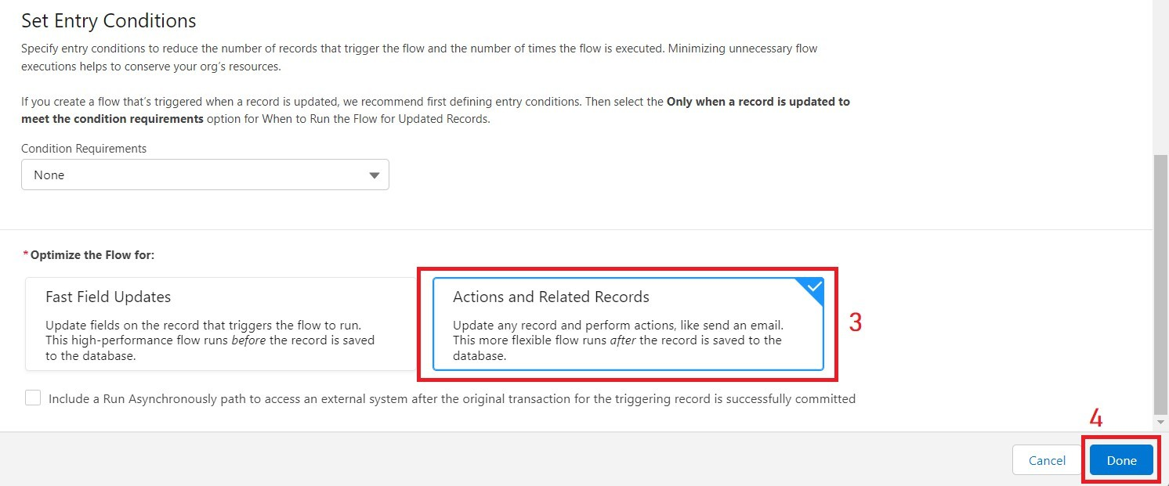

1. UndertheRecord-triggeredFlowClickon“+”SymbolandIntheDropdownList select the “Update records Element”.

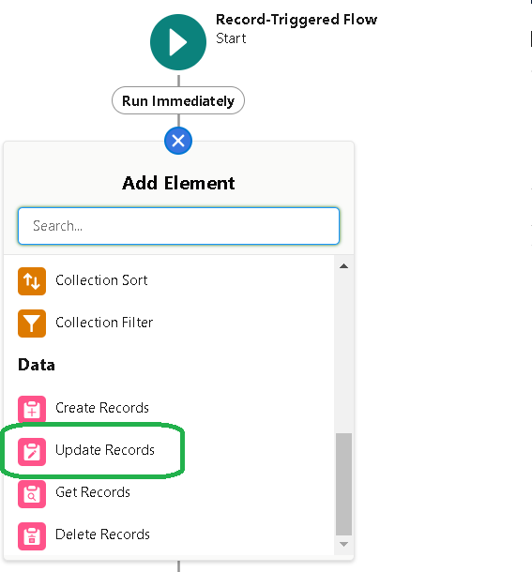

1. Give the Label Name : Amount Update
2. Api name : is auto populated

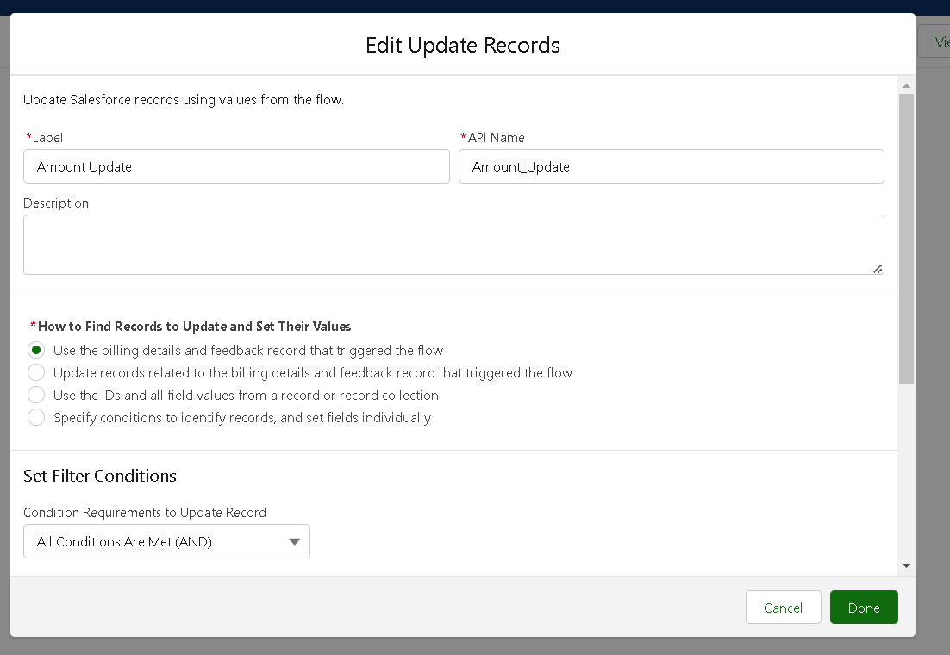

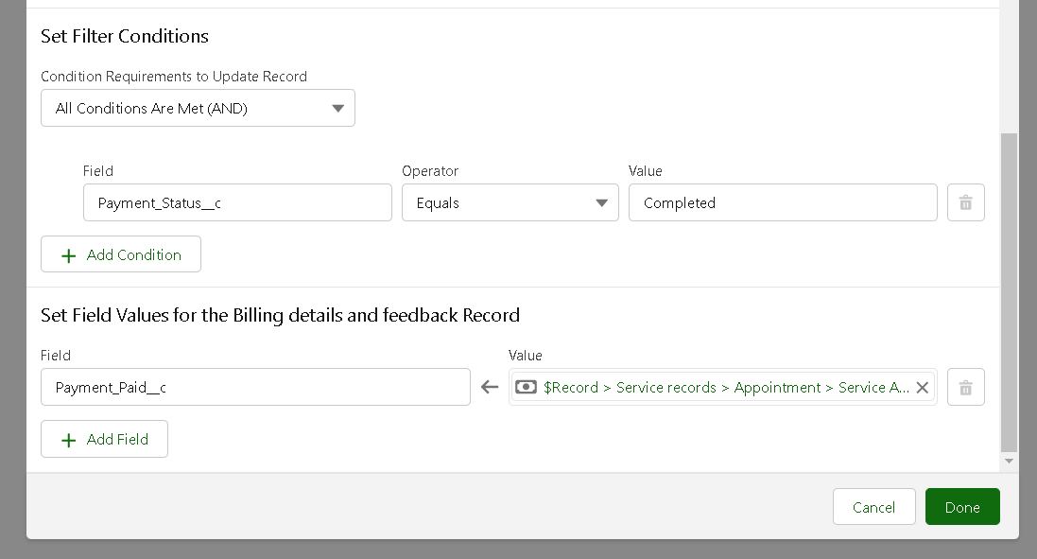

1. Set a filter condition : All Conditions are met(AND)
2. Field : Payment_Statusc
3. Operator : Equals
4. Value:Completed
5. AndSetFieldValuesfortheBillingdetailsandfeedback Record
6. Field: Payment_Paidc
7. Value:{!$Record.Service_recordsr.Appointmentr.Service_Amountc}
8. Click On Done.
9. BeforecreatinganotherElement.CreateaNewResourceformToolboxformtopleft.

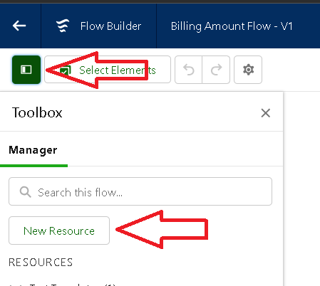

1. Click on the New Resource, And select Variable.
2. Select the resource type as text template.
3. Enter the API name as “ alert”.
4. ChangetheviewasRichText→ViewtoPlainText.
5. Inbodyfieldpastethesyntaxthatgivenbelow. Dear

{!$Record.Service_recordsr.Appointmentr.Customer_Namer.Name},

I hope this message finds you well. I wanted to take a moment to express my sinceregratitude for your recent payment for the servicesprovidedbyourgaragemanagementteam. Your prompt payment is greatly appreciated, and it helps us continue to provide top-notch services to you and all our valued customers.

Amountpaid:{!$Record.Payment_Paidc} Thank you for Coming .

1. Click done.

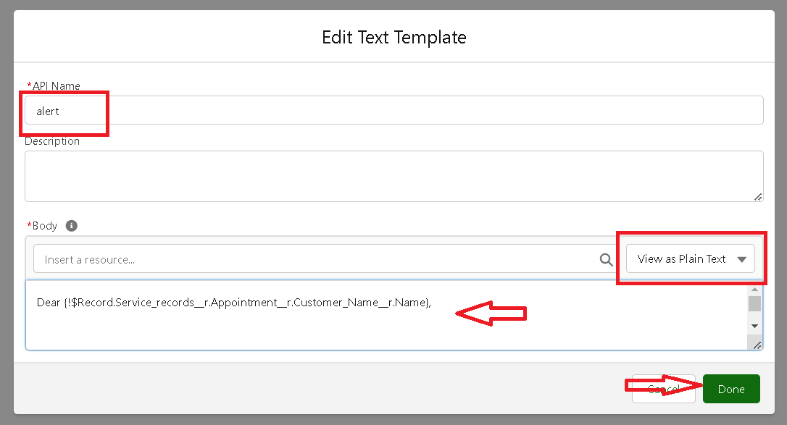

1. Now Click on Add Element , select Action.
2. Their action bar will be opened in that search for “ send email ” and click on it.
3. Give the label name as “ Email Alert”
4. API name will be auto populated.
5. Enable the body in set input values for the selected action.
6. Select the text template that created , Body : {!alert}
7. Include recipient address list select the email form the record.
8. RecipientAddressList:

{!$Record.Service_recordsr.Appointmentr.Customer_Namer.Gmailc}

1. Includesubjectas“ThankYouforYourPayment-GarageManagement”.
2. Click done.

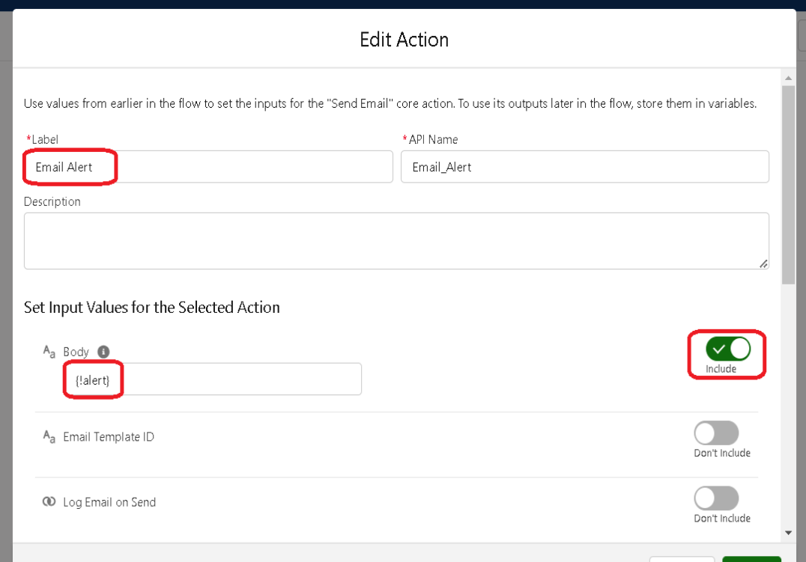

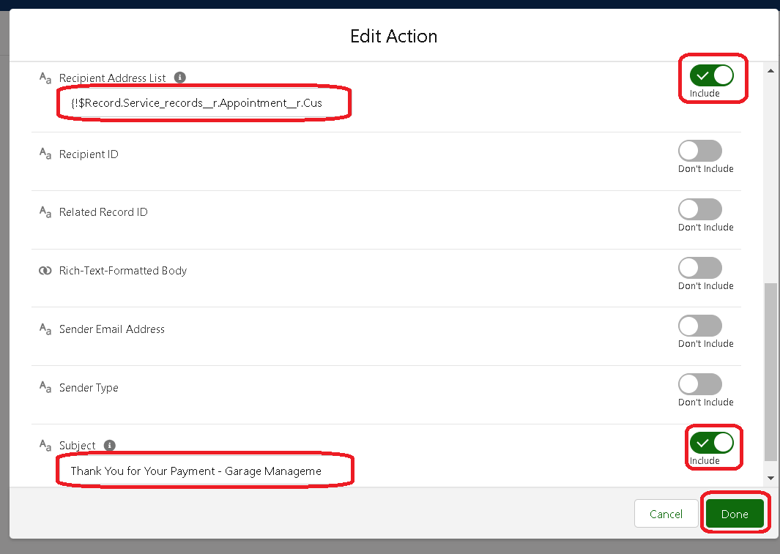

1. Click on save. Give the Flow label , Flow Api name will be autopopulated.
2. And click save, and click on activate.

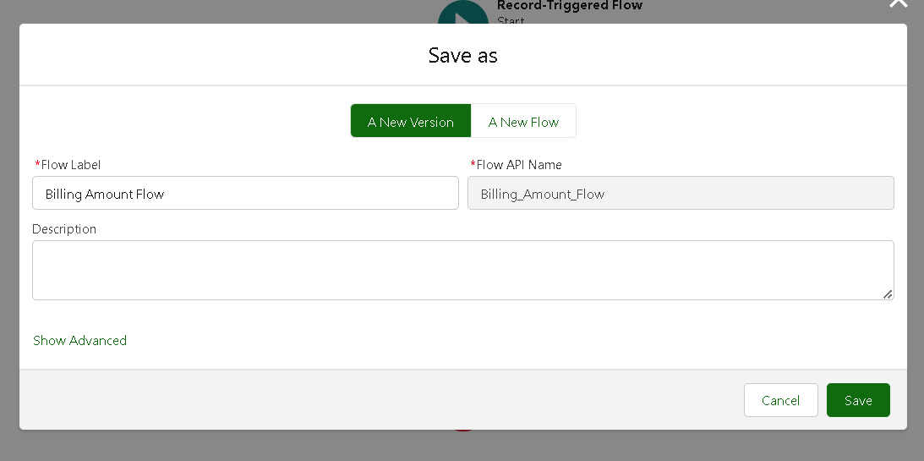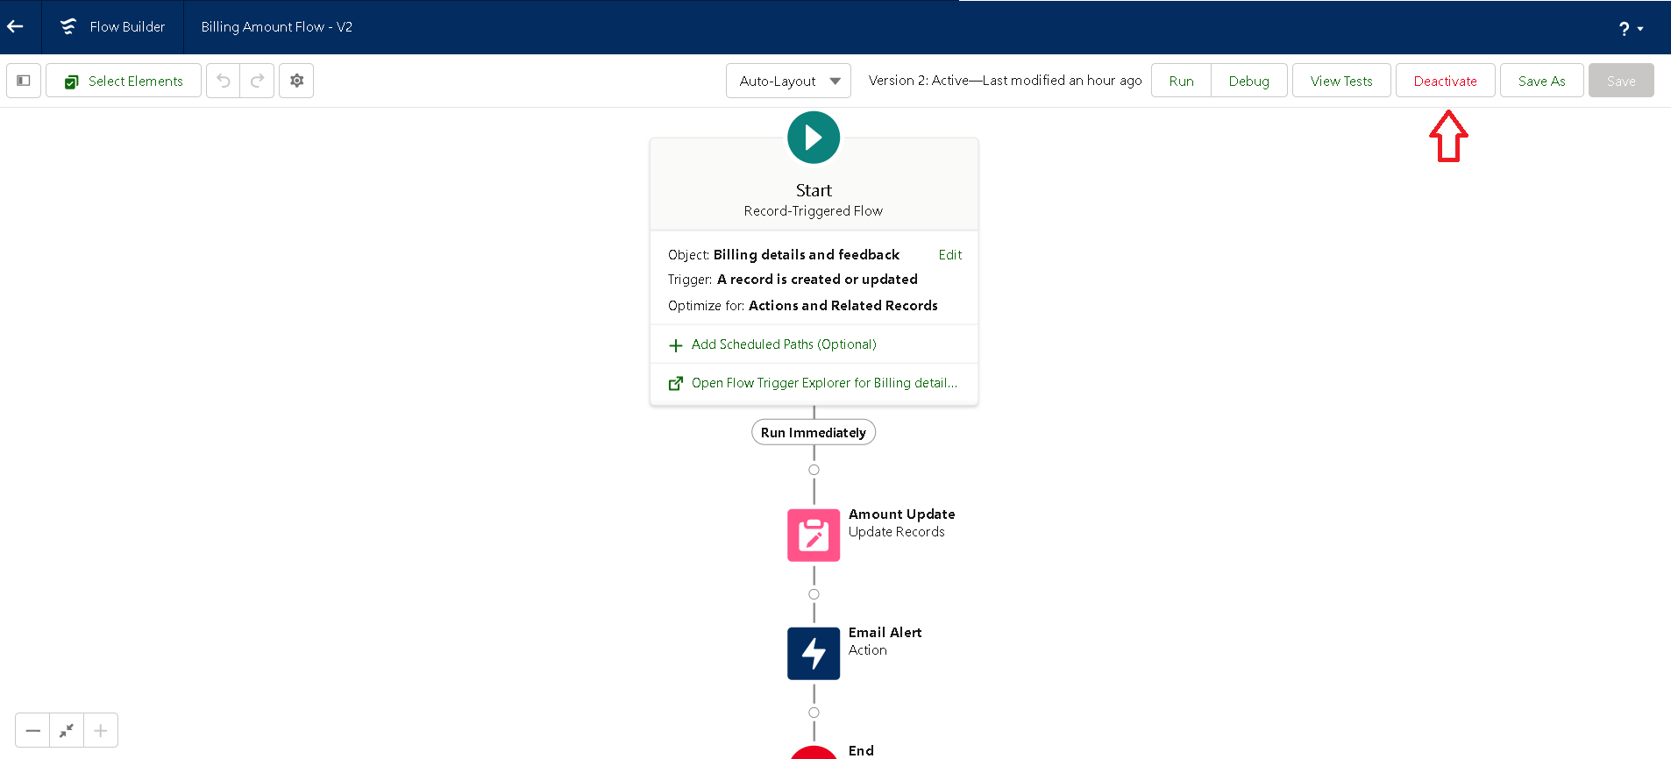

## Activity2:CreateanotherFlow

1. Go to setup → type Flow in quick find box →ClickontheFlowandSelecttheNew Flow.

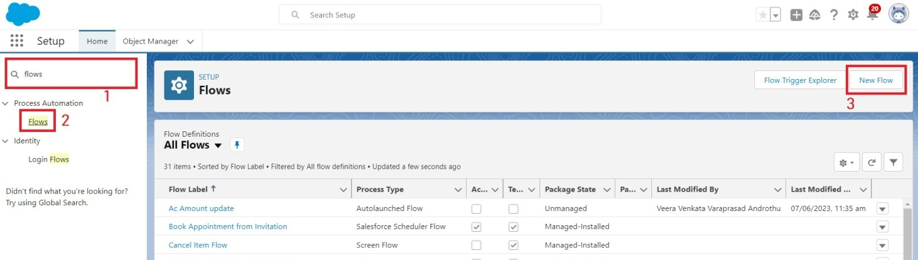

1. Select the Record-triggered flow and Click on Create.



1. Select the Object as “ Service records”in the Drop down list.
2. SelecttheTriggerFlowwhen:“ArecordisCreatedor Updated”.
3. Select the Optimise the flow for: “Actions and Related Records” and Click on Done.
4. UndertheRecord-triggeredFlowClickon“+”SymbolandIntheDropdownList select the “Update records Element”.
5. Set a filter condition : All Conditions are met(AND)
6. Field : Quality_Check_Statusc
7. Operator : Equals
8. Value:True
9. AndSetFieldValuesfortheBillingdetailsandfeedback Record
10. Field: Service_Statusc
11. Value:Completed

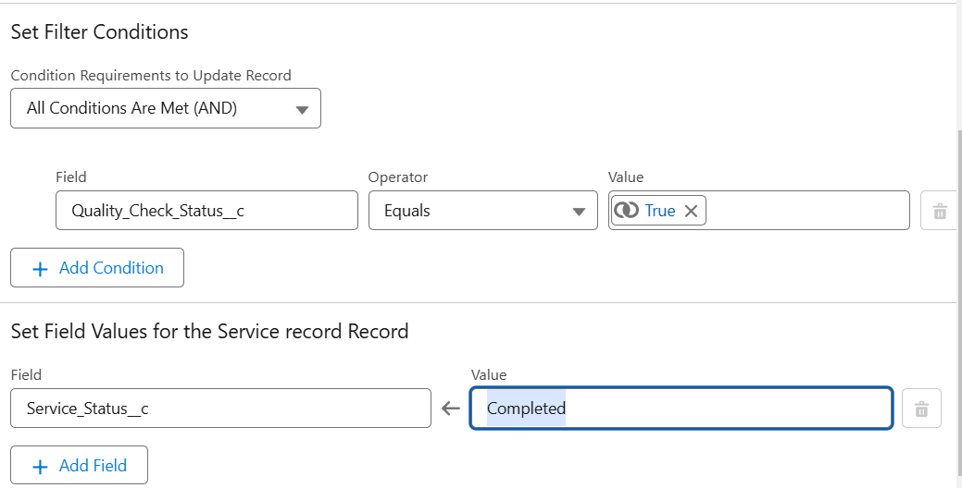

1. Click On Done.
2. Click on save
3. GiventheFlowlabelas**UpdateServiceStatus**,FlowApinamewillbeautopopulated.
4. And click save, and click on activate.

**Milestone14:ApexTrigger**

Apexcanbeinvokedbyusingtriggers.Apextriggersenableyoutoperformcustomactions before or after changes to Salesforce records, such as insertions, updates, or deletions.

A trigger is Apex code that executes before or after the following types of operations:

* insert
* update
* delete
* merge
* upsert
* undelete

For example, you can have a trigger run before an object's records are inserted into the database, after records have been deleted, or even after a record is restored from the Recycle Bin.

You can define triggers for top-level standard objects that support triggers, such as a Contact or an Account, some standard child objects, such as aCaseComment,andcustom objects. To define a trigger, from the object management settings for the object whose triggers you want to access, go to Triggers.

There are primarily two types of Apex Triggers:

**Before Trigger:** This type of trigger in Salesforce is used either to update or validate the values of a record before they can be saved into the database. So, basically, the before trigger validates the recordfirstandthensavesit.Somecriteriaorcodecanbesettocheck data before it gets ready to be inserted into the database.

**After Trigger:** This type of trigger in Salesforce is used to access the field values set by the system and affect any change in the record. In other words, the after trigger makes changes to the value from the data inserted in some other record.

## Activity-1:Apexhandler

**UseCase:ThisusecaseworksforAmountDistributionforeachServicethecustomer selected for there Vehicle.**

1. Logintotherespectivetrailheadaccountandnavigatetothegeariconin the top right corner.
2. ClickontheDeveloperconsole.Nowyouwillseeanewconsole window.
3. Inthetoolbar,youcanseeFILE.Clickonitandnavigatetonewand create New apex class.
4. Nametheclassas“AmountDistributionHandler”.

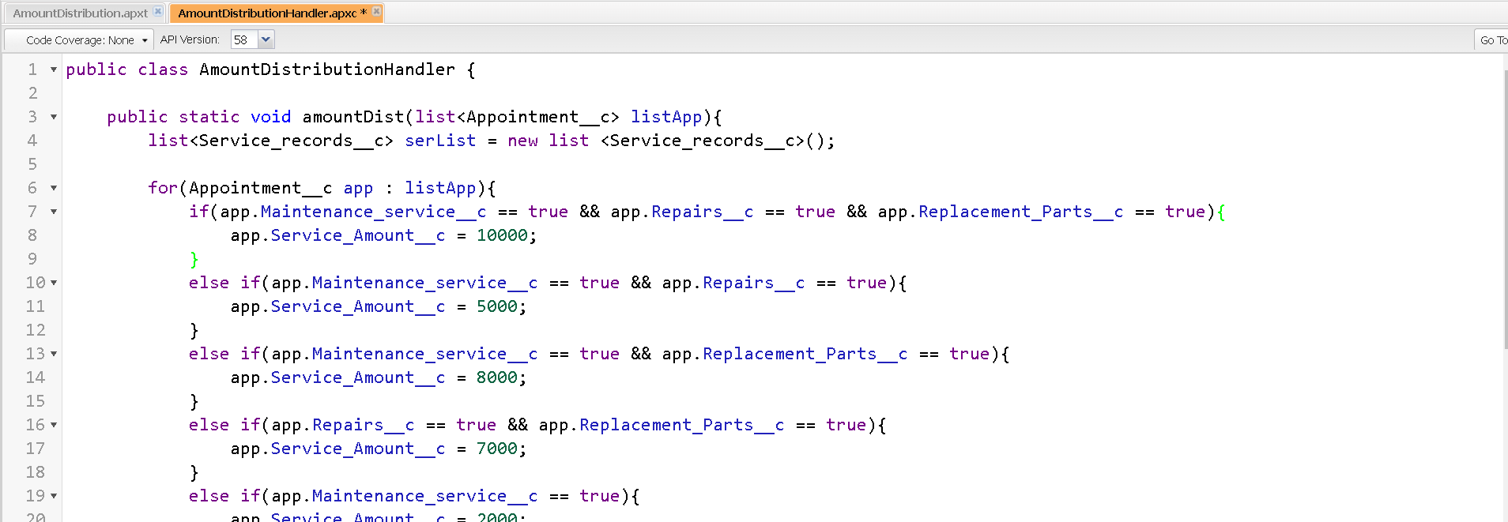

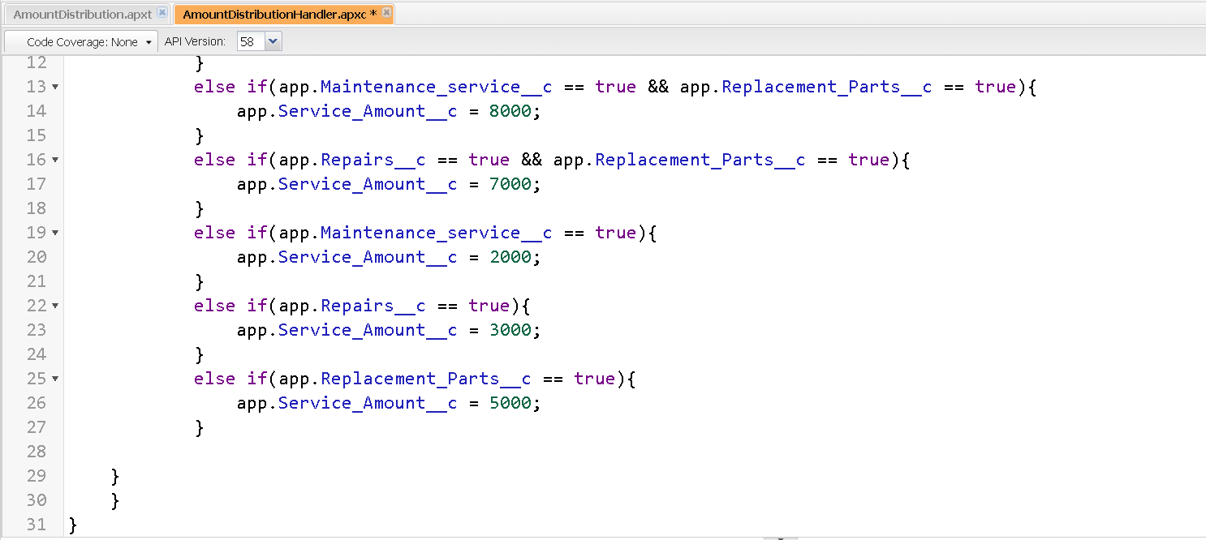

## Code:

publicclassAmountDistributionHandler{

public static void amountDist(list<Appointment c> listApp){ list<Service_records c> serList = new list <Service_records c>();

for(Appointment capp:listApp){

if(app.Maintenance_service c == true && app.Repairs c==true&&app.Replacement_Parts c == true){

app.Service_Amount c=10000;

true){

}

elseif(app.Maintenance_service c==true&& app.Repairs c==

app.Service_Amount c=5000;

}

elseif(app.Maintenance_service c==true&&

app.Replacement_Parts c == true){ app.Service_Amount c=8000;

}

elseif(app.Repairs c==true&& app.Replacement_Parts c==true){

app.Service_Amount c=7000;

}

else if(app.Maintenance_service c==true){ app.Service_Amount c = 2000;

}

else if(app.Repairs c == true){ app.Service_Amount c=3000;

}

else if(app.Replacement_Parts c==true){ app.Service_Amount c = 5000;

}

}

}

}

## TriggerHandler:

**Howtocreateanewtrigger :**

1. Whilestill in the trailhead account, navigate to the gear icon in the top right corner.
2. Clickon developer console and you will be navigated to a new console window.
3. ClickonFilemenuinthe toolbar,andclickonnew→ Trigger.
4. Enter the trigger name and the object to be triggered.
5. Name: AmountDistribution
6. sObject : Appointmentc

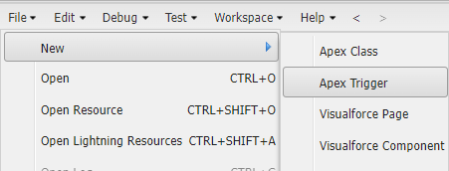

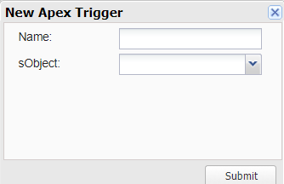

## SyntaxForcreatingtrigger:

The syntax for creating trigger is :

Trigger[triggername]on[objectname](Before/Afterevent)

{

}

Inthisproject,triggeriscalledwhenevertheparticularrecordssumexceedthethresholdi.e minimum business requirement value. Then the code in the trigger will get executed.

1. Handler for the Appointment Object

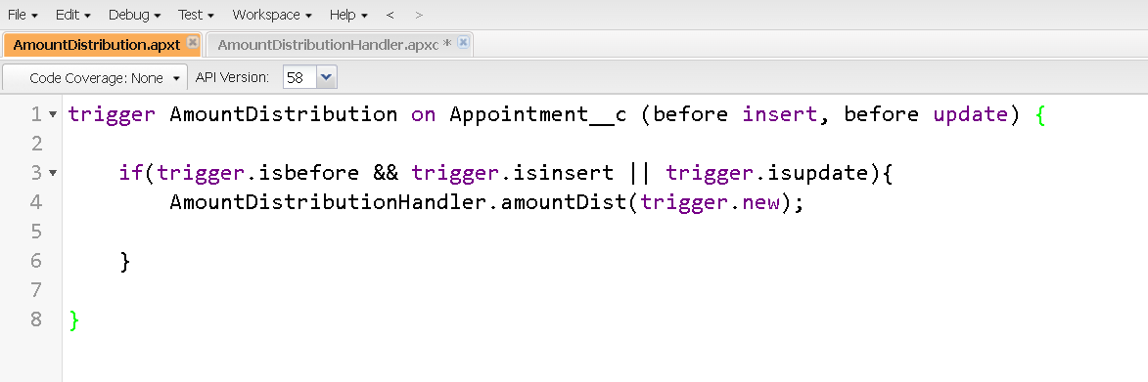

Code:

trigger AmountDistribution on Appointmentc (before insert, before update) {

if(trigger.isbefore&&trigger.isinsert||trigger.isupdate){ AmountDistributionHandler.amountDist(trigger.new);

}

}

## Milestone-15:UserAdoption Activity 1 : creating record

Tocreatearecordinthefollowobjectsfollowthesesteps

1. Click on the app launcher located at the left side of the screen.
2. Search for “ Garage Management” and click on it.
3. Click on the “ Consumer details tab”.
4. Click on new and fill the details as shown below figs, and click save.

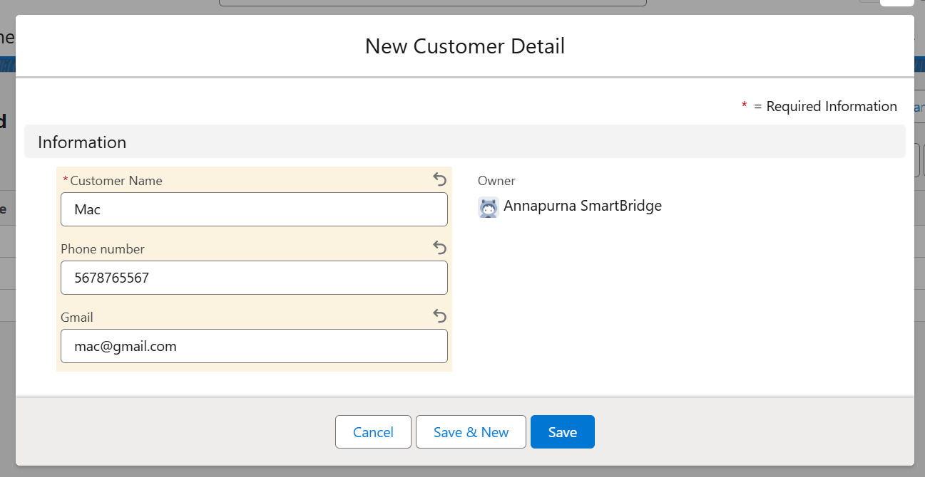

Now,CreatetheAppointmentRecord

1. Click on the “Appointment tab”.
2. Enterthecustomerdetailsascreated,whileentering**AppointmentDate**enterthe date less than the created date.
3. Match the validation while entering the **vehicle number plate.**
4. Select the services you need.
5. Click on save to see the **Service Amount.**

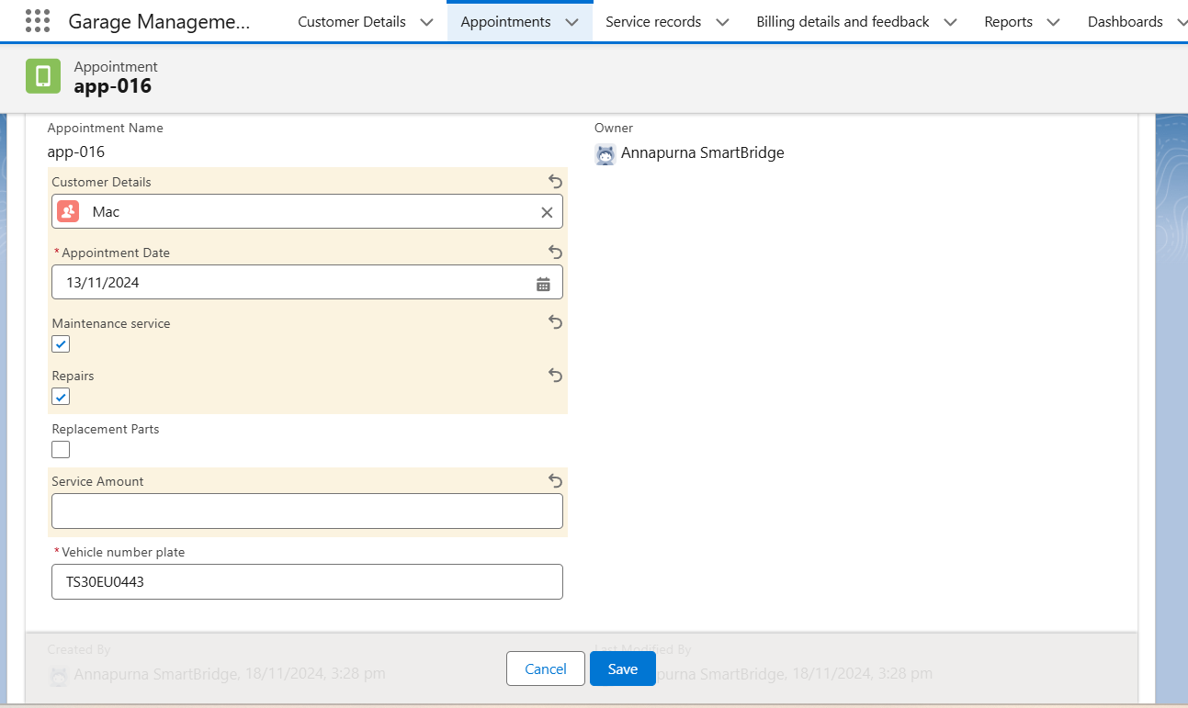

Now,CreateaserviceRecord

1. Click on the “Service record tab”.
2. Enter the Appointment, and started is selected as default.
3. Click on save.

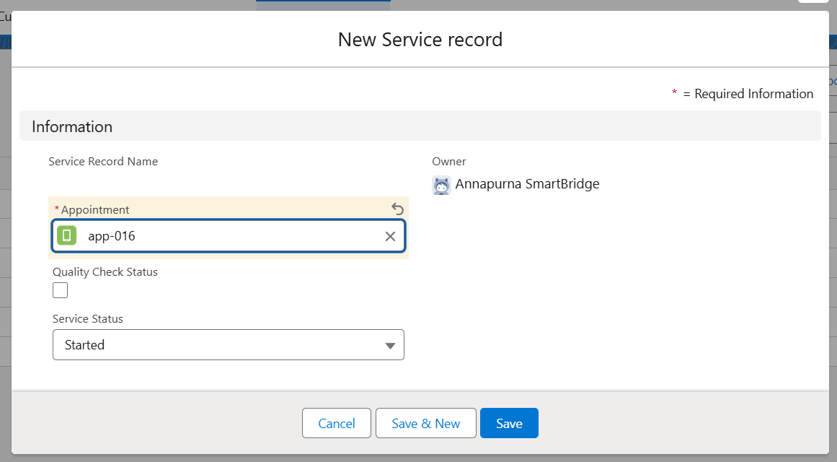

1. Open the record and click on Quality check status as true.
2. Click on save.

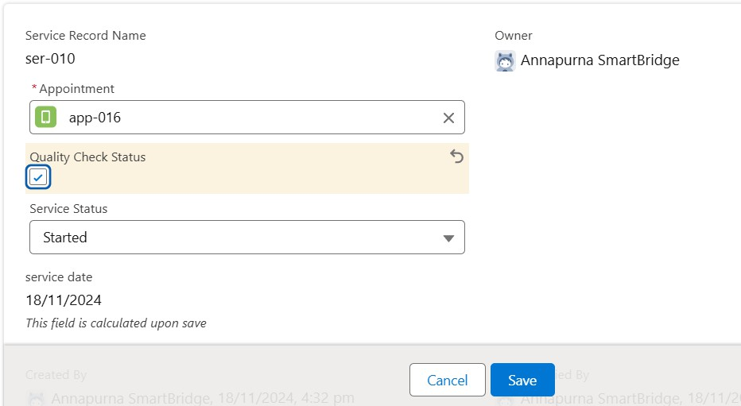

1. Now automatically Service status will be moved to completed.

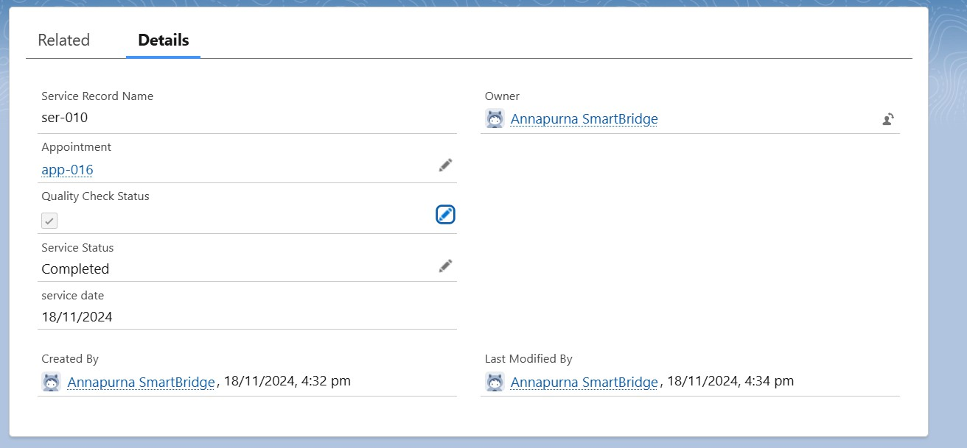

## Milestone16:Reports

Reports give you access to your Salesforce data. You can examine your Salesforce data in almost infinite combinations, display itineasy-to-understandformats,andsharetheresulting insights with others. Before building, reading, and sharing reports, review these reporting basics.

TypesofReportsinSalesforce

1. Tabular
2. Summary
3. Matrix
4. Joined Reports

## Activity1:createareportfolder

1. Click on the app launcher and search for reports.
2. Click on the report tab, click on new folder.

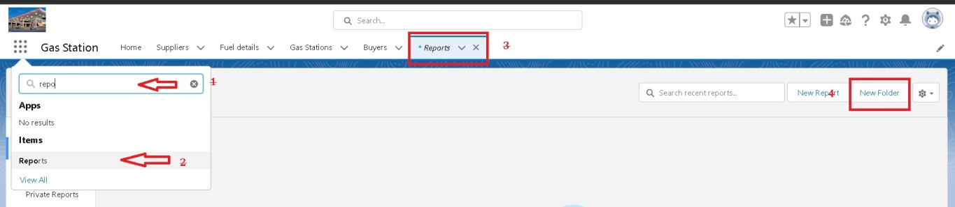

1. Give the Folder label as “Garage Management Folder”,Folderuniquenamewillbeauto populated.
2. Click save.

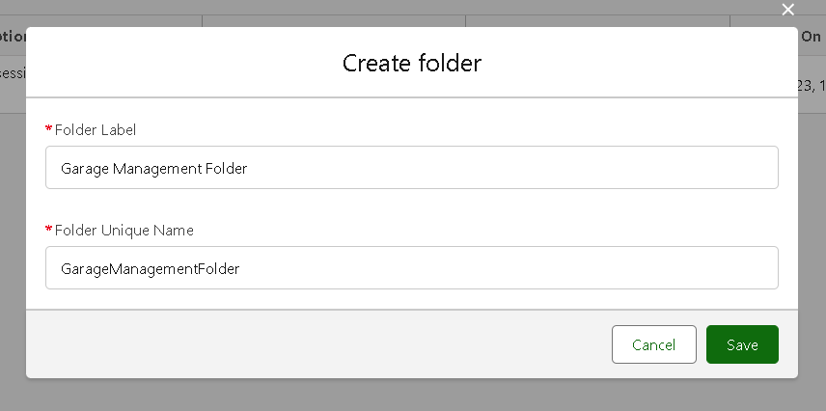

## Activity2:Sharingareportfolder

1. Go to the app → click on the reports tab.
2. ClickontheAll folder , click on the Drop down arrow for Garage Management folder, and Click on share.
3. Selectthesharewithas“roles”,innamefieldsearchfor“manager”,give“view”as access for that role.
4. Then click share, and click on Done.

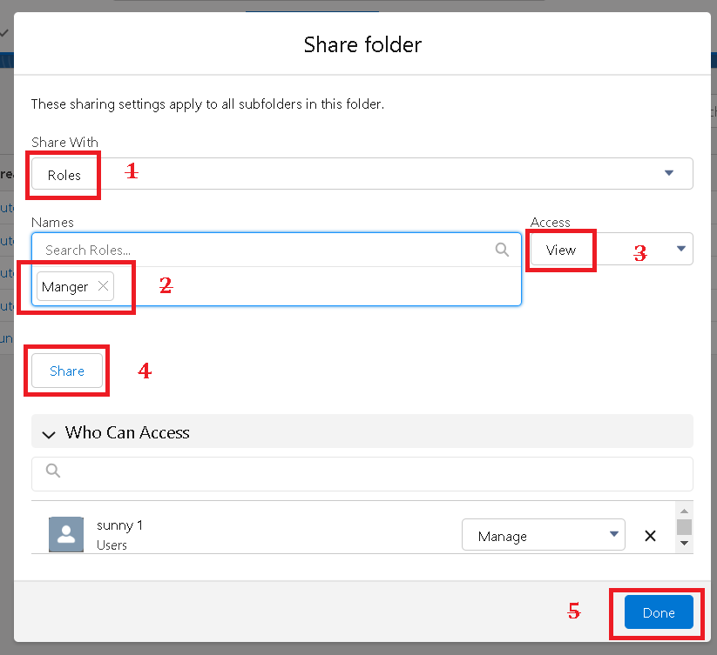

## Activity3:CreateReportType

* 1. Gotosetup→typeusersinquickfindbox→selectReportType→clickonContinue.
  2. Click on new custom report type.

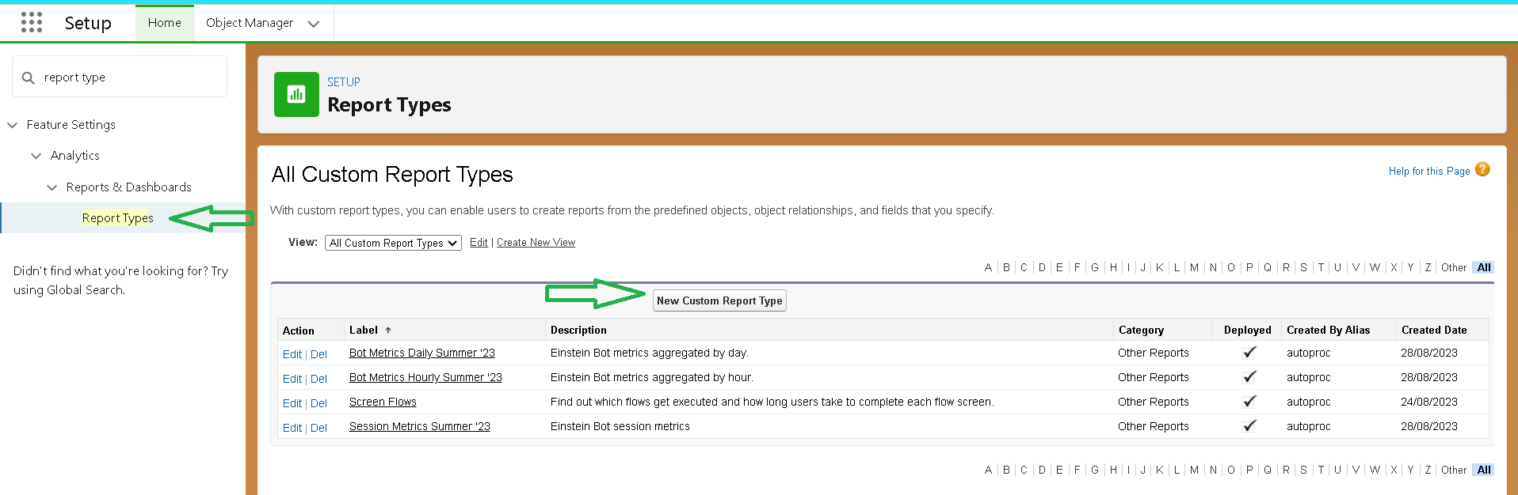

* 1. SelectthePrimaryobjectas“Customerdetails”.
  2. GivetheReporttypeLabelas“Serviceinformation”
  3. ReporttypeNameisautopopulated.
  4. KeeptheDescriptionassame.
  5. SelectStoreinCategoryas“otherReports”
  6. Selectthedeploymentstatusas“Depolyed”,clickonNext.

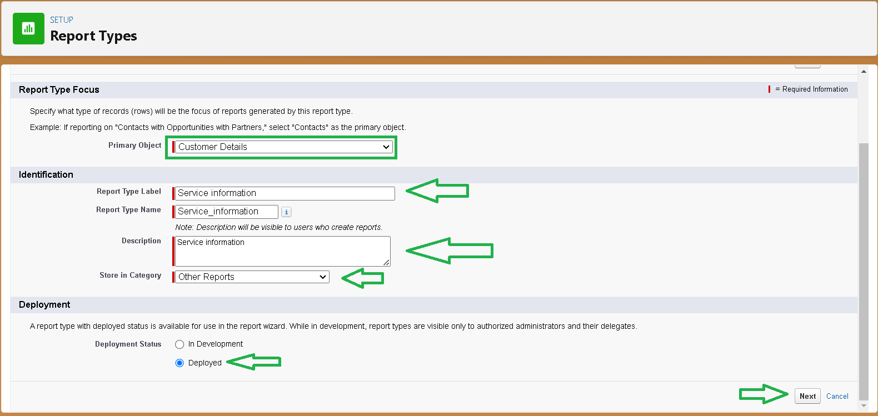

* 1. now,ClickonRelatedobject box.
  2. ClickonSelectObject,chooseAppointmentObjectasshowninfig.

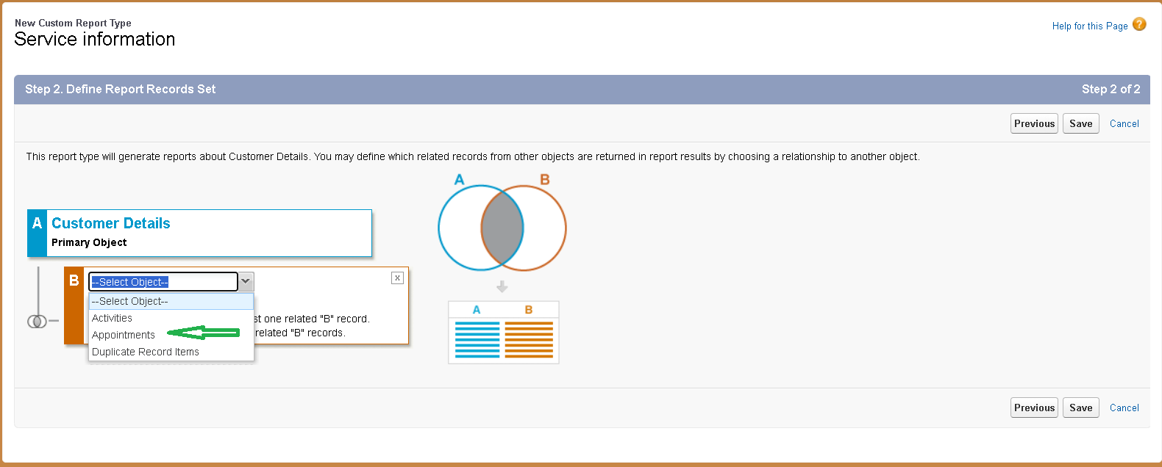

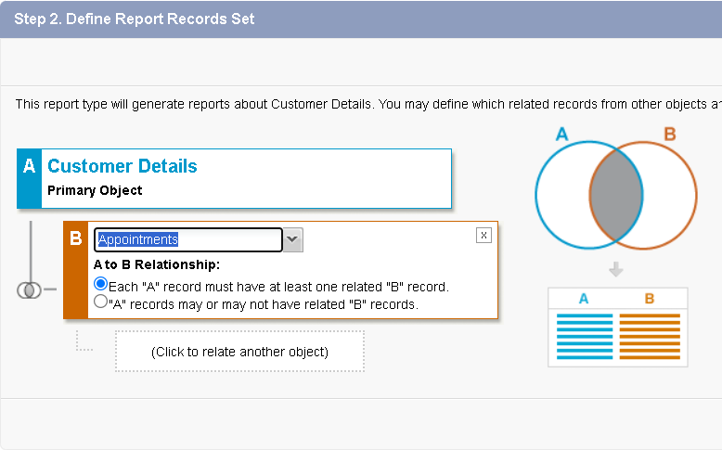

* 1. AgainClicktorelateanotherobject.
  2. Andselecttherelatedobjectas“servicerecords”.
  3. Repeattheprocessandselecttherelatedobjectas“Billingdetailsandfeedback”.
  4. Andclickonsave.

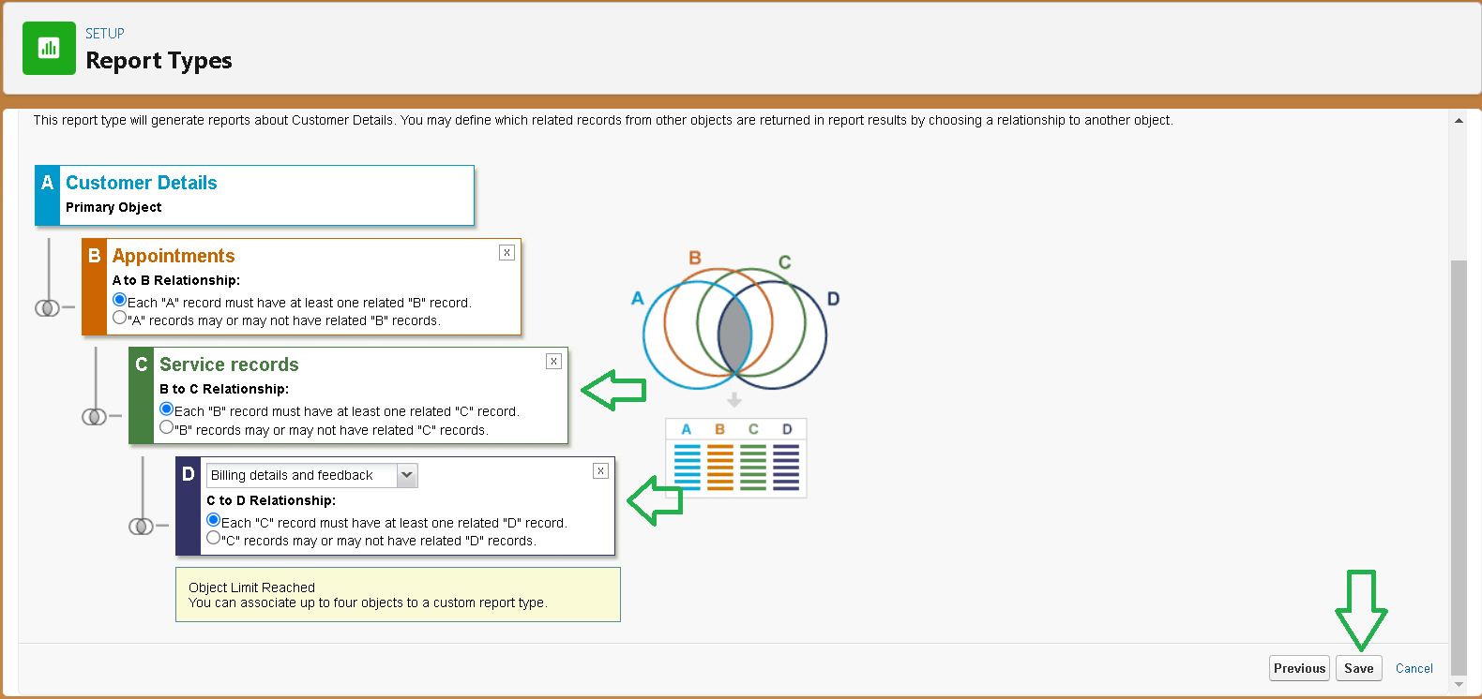

## Activity4:CreateReport

#### Note:Beforecreatingreport,createlatest“10”recordsineveryobject. Try to fill every field in each record for better experience.

1. Go to the app → click on the reports tab
2. Click New Report.

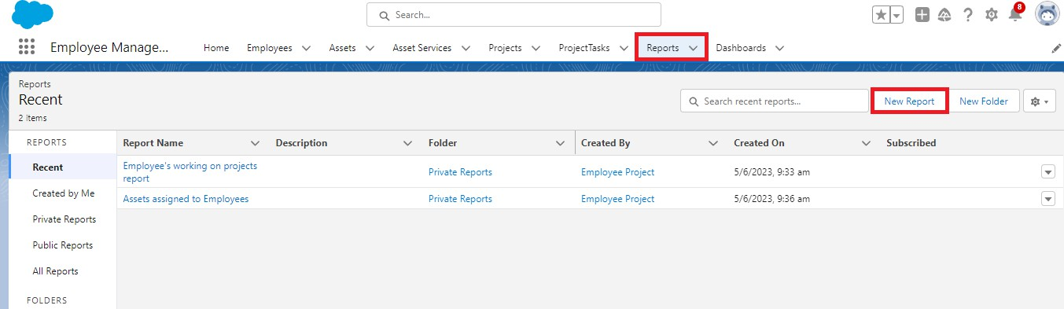

1. SelecttheCategoryasotherreports,searchforServiceInformation,selectthat report, click on it. And click on start report.

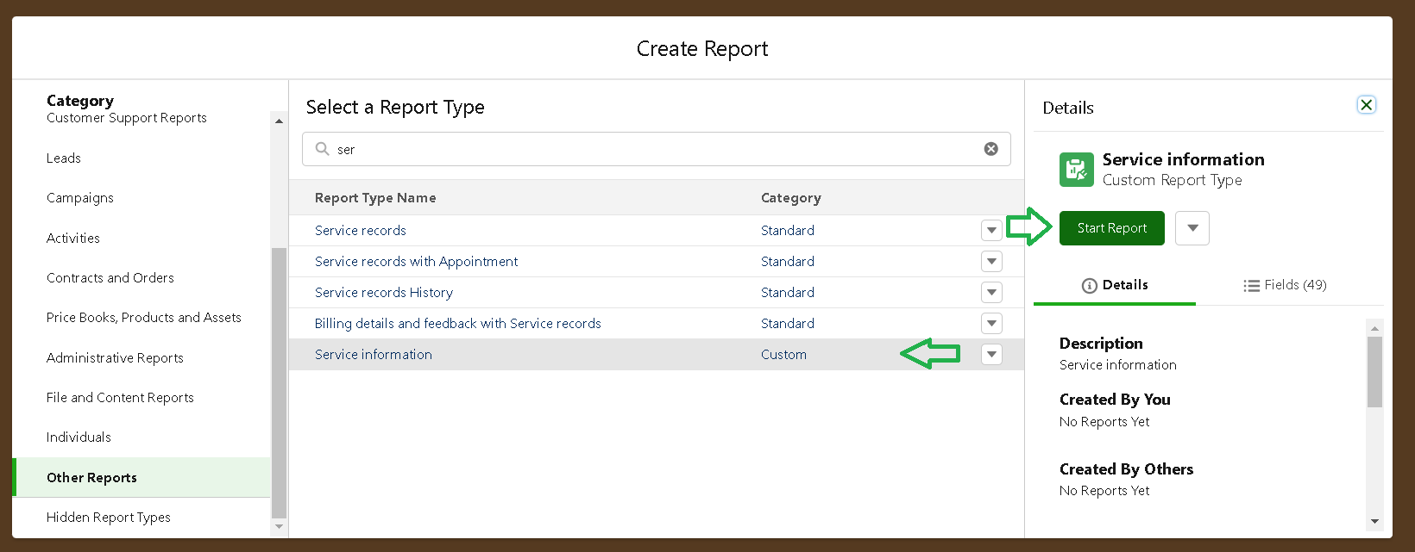

1. Theiroutlinepaneisopenedalready,selectthefieldsthatarementionedbelowin the column section.
   1. Customer name
   2. Appointment Date
   3. Service Status
   4. Payment paid
2. Remove the unnecessary fields.
3. Select the fields that mentioned below in GROUP ROWS section.
   1. Rating for Service
4. Select the fields that mentioned below in GROUP ROWS section.
   1. Payment Status
5. Click on Add Chart , Select the Line Chart.
6. Click on save, Give the report Name : New Service information Report
7. Report unique Name is auto populated.
8. Select the folder the created and Click on save.

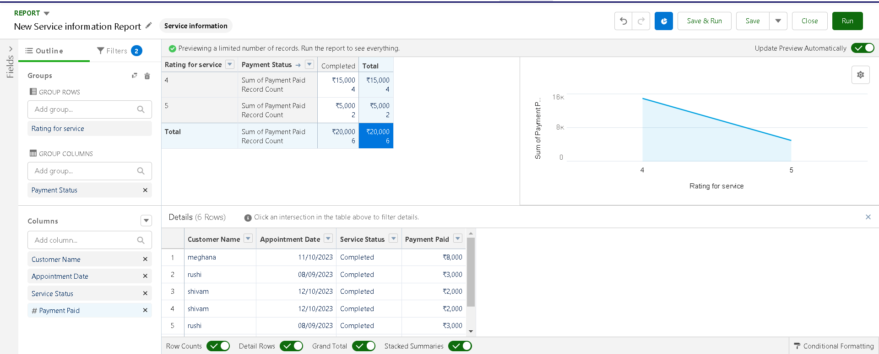

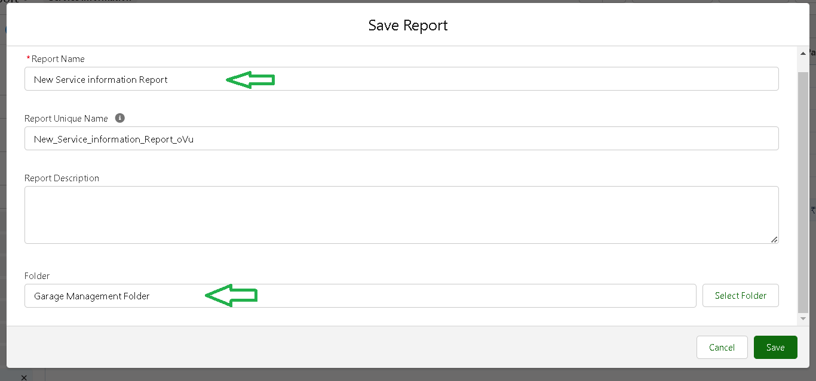

## Milestone17:Dashboards

Dashboards help you visually understand changing business conditions so you can make decisions based on the real-time data you’ve gathered with reports. Use dashboards to help users identify trends, sort out quantities, and measure the impact of their activities. Before building, reading, and sharing dashboards, review these dashboard basics.

#### Activity1:CreateDashboardFolder

1. Click on the app launcher and search for dashboard.
2. Click on dashboard tab.
3. Clicknewfolder,givethefolderlabelas“ServiceRating dashboard”.
4. Folder unique name will be auto populated.
5. 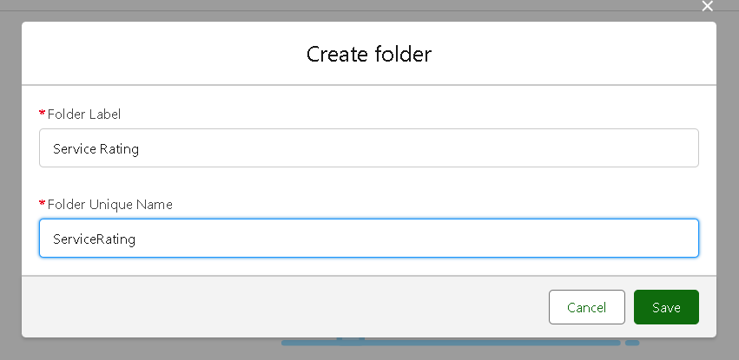Click save.
6. Followthesamesteps,formmilestone15,andactivity2,andprovidethesharingsettings for the folder that just created.

#### Activity2:CreateDashboard

1. Go to the app → click on the Dashboards tabs.
2. Give a Name and select the folder that created, and click on create.

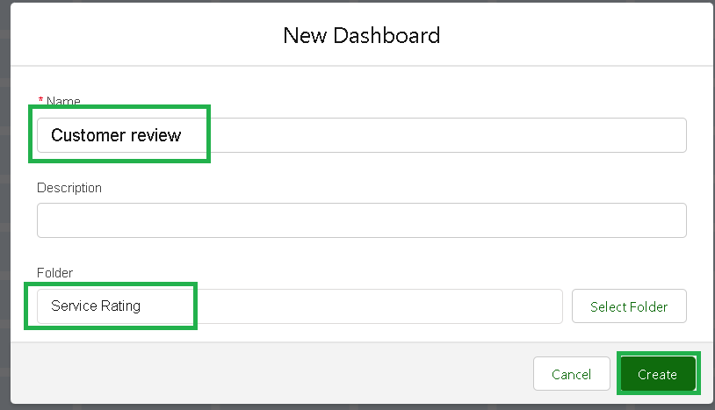

1. Select add component.



1. Select a Report and click on select.

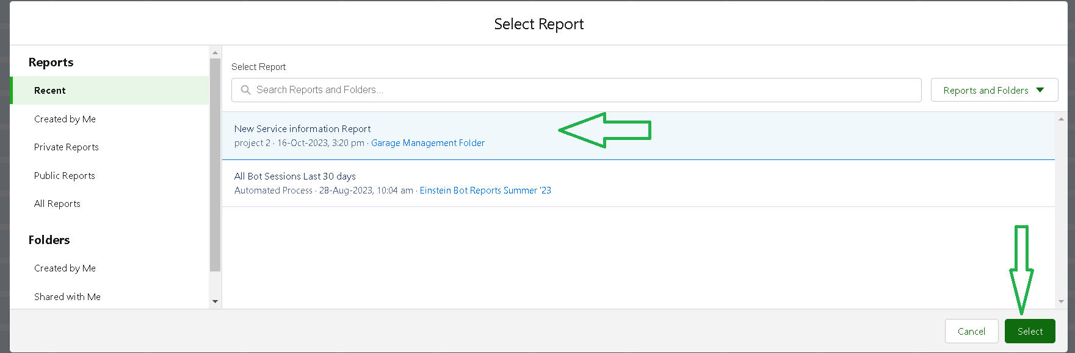

1. Select the Line Chart. Change the theme.
2. Click Add then click on Save and then click on Done.
3. Preview is shown below.

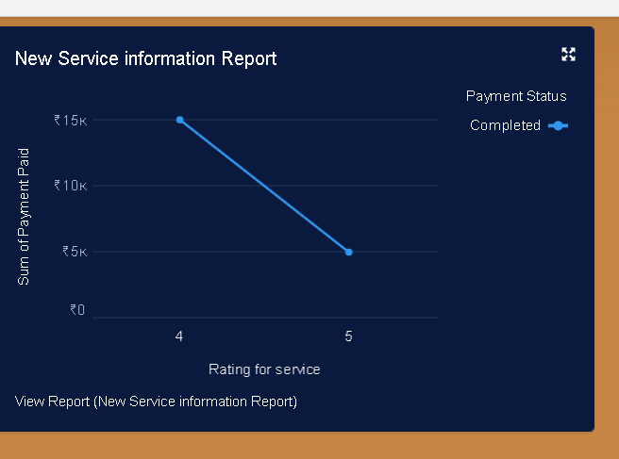

1. After that Click on Subcribe on top right.
2. Set the Frequency as “ weekly ”.
3. Set a day as monday.
4. And Click on save.

